Contracts

Downloaded from the LEITI database [14 contracts]
https://www.leiti.org.lr/index.php/publications/document-type/forestry

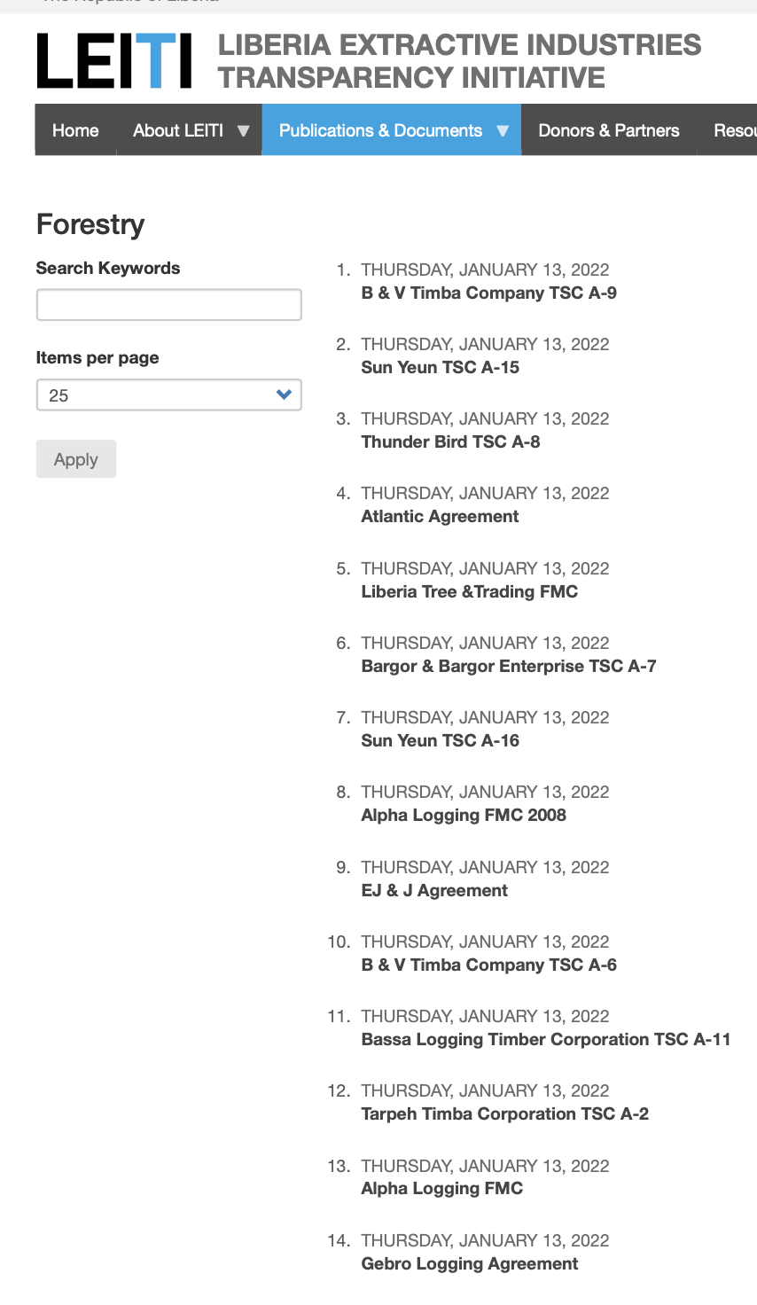

The Open Land Contracts database
https://www.openlandcontracts.org/countries/lr
