# Financial Status

## CFMA Bluyeama – Sing Africa

**Sofreco final report**

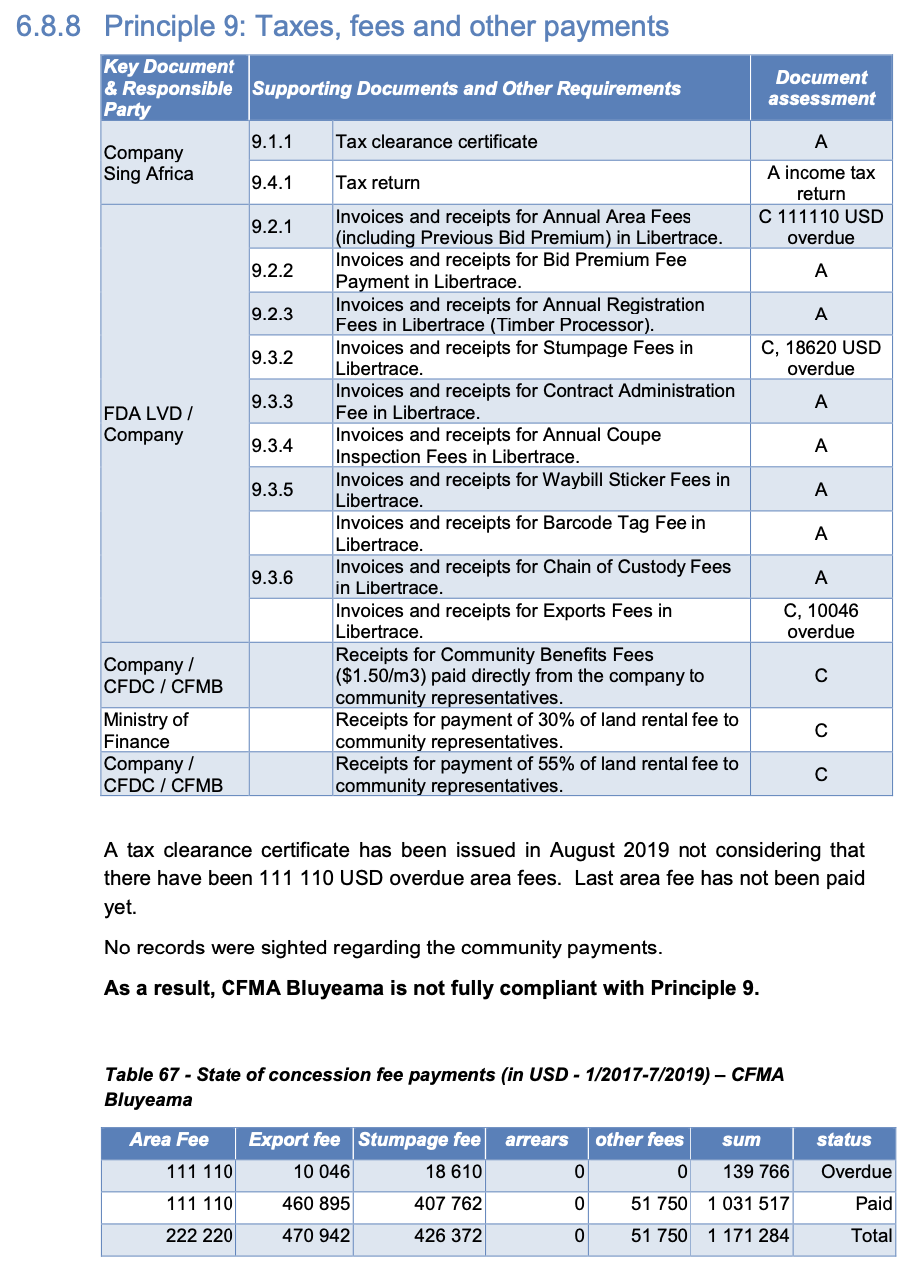

**Libertrace – most recent data (May 2022[1])**

Invoiced – $78,138.93for May 2022 [$76,638.93 stumpage {unpaid} & $1,500 other fees* {paid}]

Paid – $1,500

Balance Due – $76,638.93

*Waybill sticker [p.31]

**LEITI – most recent data (2019[2])**

Payments FY19 – $430,032

On production of 5,713 m3

Exports $109,328

**Land rental arrears (2019) – Forest Trends report[3]**

No mention

1. <https://libertrace.sgs.com>

   Monthly Performance Report May 2022
2. <https://www.leiti.org.lr/sites/default/files/documents/LEITI%2013th%20Report%20final.pdf>

   13th REPORT 2019 - 2020
3. https://www.forest-trends.org/publications/community-benefits-sharing-in-the-forestry-sector-liberias-legislative-framework-track-record-on-sharing-land-rental-fees-from-commercial-forestry-2007-2019/