Financial Status

FMC F – Euro Logging

Sofreco final report
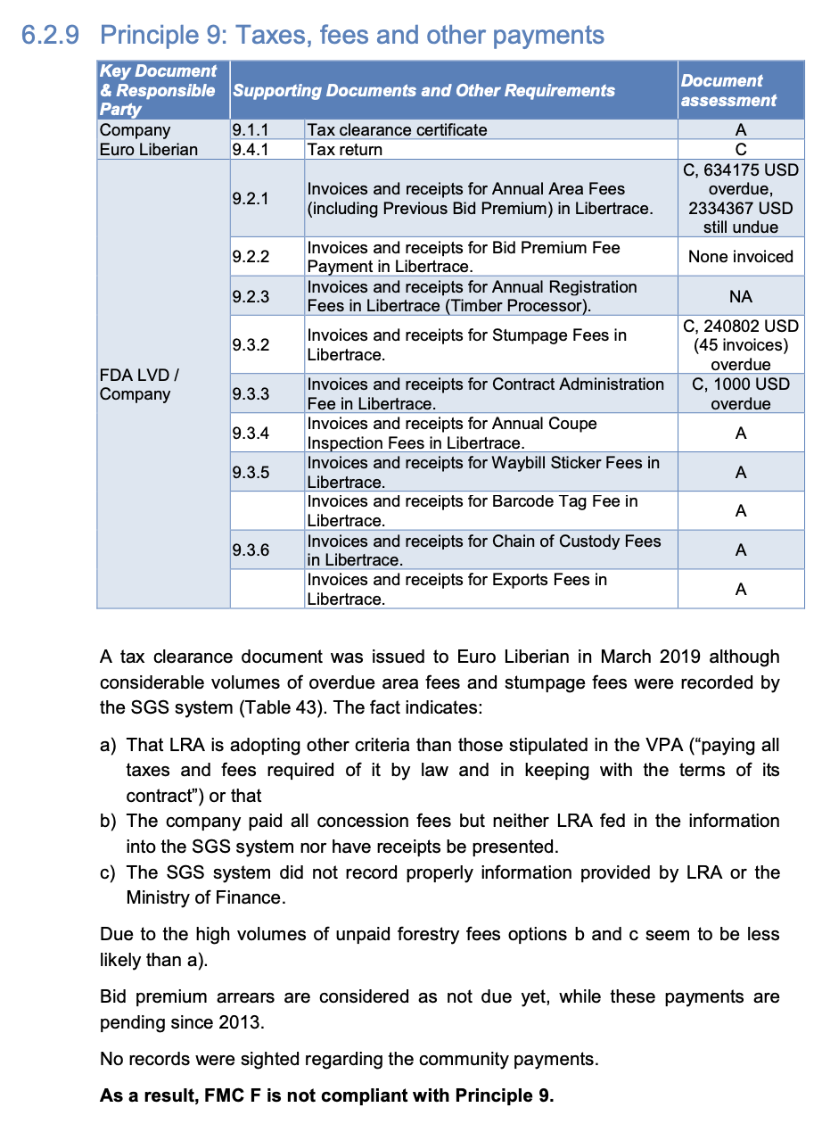

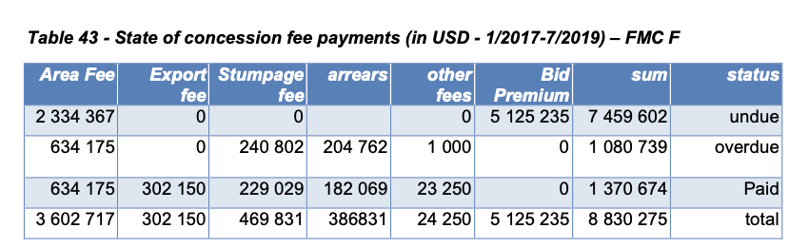

Libertrace – most recent data (May 2022)
Invoiced – $794,962.59 for May 2022 [$306,384.98 stumpage & $304,769.28 Export fees & $183,808.33 other fees*]
Paid – $794,962.59
Balance Due – $0

*“Euro Liberia Logging paid 178,058.33 in line with the company payment plan” [p.5]

LEITI – most recent data (2019)
Payments FY19 – none noted

But $191,168 in exports [p.69] from a 253,670 ha (18.2% of all FMCs) operation [p.58] and 8,823 m³ of logs produced [p.116]

Land rental arrears (2019) – Forest Trends report
Payments to 2017 – $5.3 million
Arrears (FY17) – $8.7 million
Land area fee arrears (Jan 2019) – $3.6 million

https://libertrace.sgs.com Monthly Performance Report May 2022
https://www.leiti.org.lr/sites/default/files/documents/LEITI%2013th%20Report%20final.pdf 13th REPORT 2019 - 2020
https://www.forest-trends.org/publications/community-benefits-sharing-in-the-forestry-sector-liberias-legislative-framework-track-record-on-sharing-land-rental-fees-from-commercial-forestry-2007-2019/

