Financial Status

CFMA Zuzohn – Booming Green

Sofreco final report
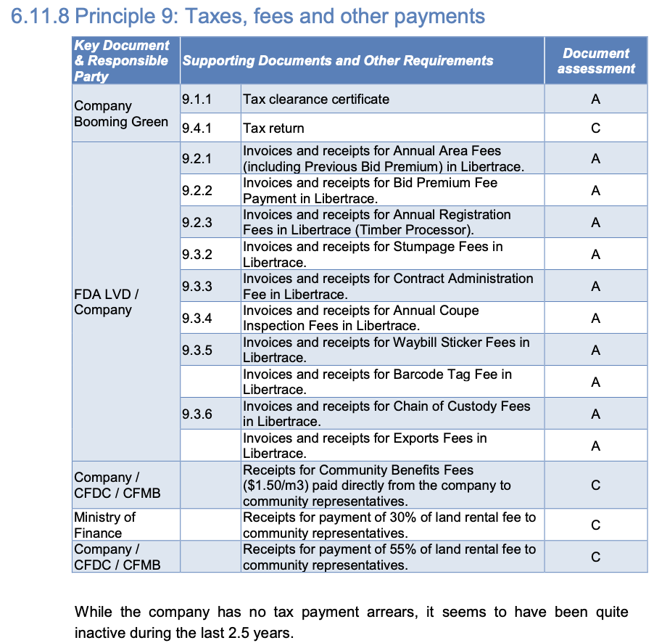

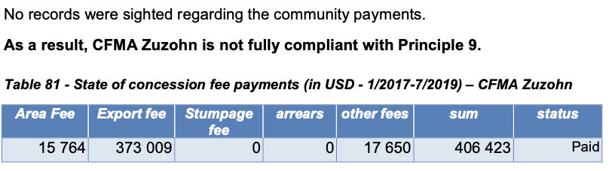

Libertrace – most recent data (May 2022)
No record

LEITI – most recent data (2019)
Payments FY19 – $649,472; $529,083 to LRA and $120,389 to NPA
On exports of 37,064 m³ worth $568,287 (14.1%) [p.69 & 115]

Land rental arrears (2019) – Forest Trends report
No record

https://libertrace.sgs.com Monthly Performance Report May 2022
https://www.leiti.org.lr/sites/default/files/documents/LEITI%2013th%20Report%20final.pdf 13th REPORT 2019 - 2020
https://www.forest-trends.org/publications/community-benefits-sharing-in-the-forestry-sector-liberias-legislative-framework-track-record-on-sharing-land-rental-fees-from-commercial-forestry-2007-2019/

