BEYANPOYE COMMUNITY FOREST
ANNUAL OPERATION PLAN FOR BEAHNPOYE COMMUNITY FOREST
MARGIBI COUNTY, LIBERIA

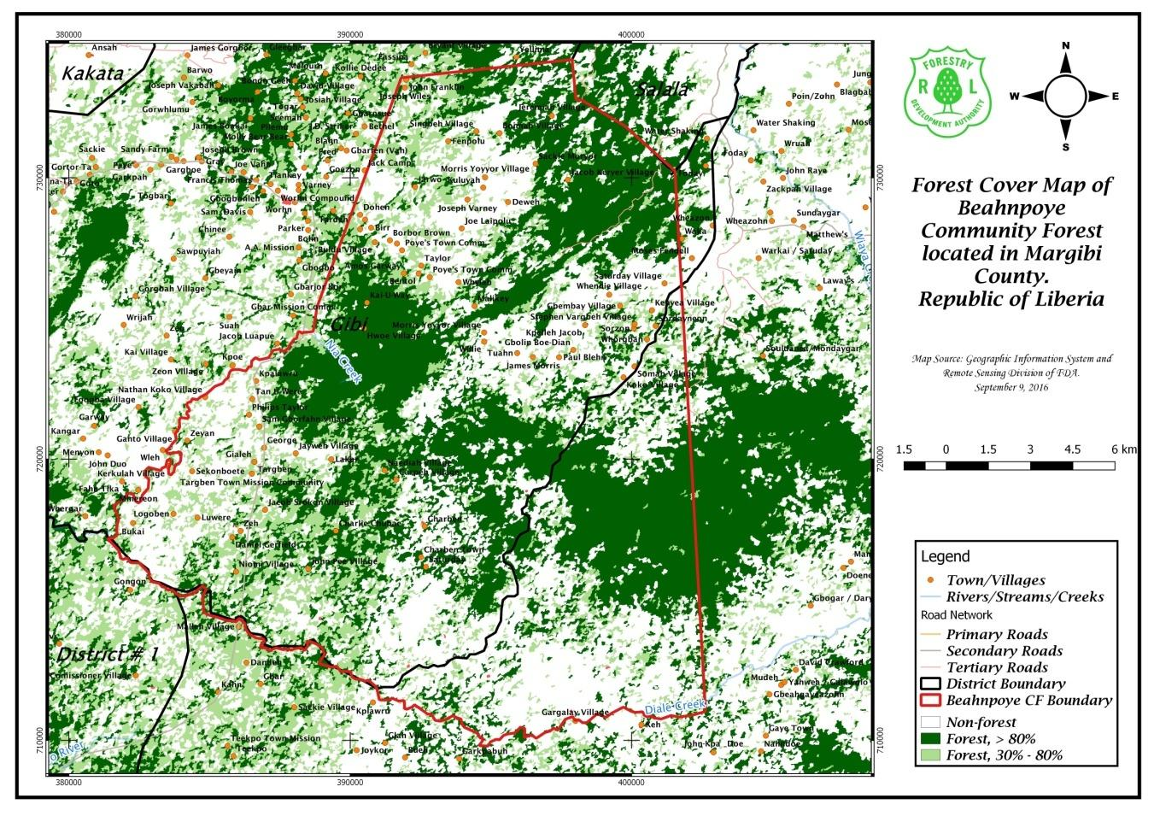

PRESENTED TO: THE FORESTRY DEVELOPMENT AUTHORITY (FDA)
WHEIN TOWN, MOUNT BARCLAY
MONROVIA, LIBERIA

TABLE OF CONTENT

1.0 Executive Summary

2.0 Reference

3.0 Assumptions

4.0 Description of the Annual Coupe Boundary

5.0 Description of Beahnpoye Forest Metes and Bounds/Technical

6.0 Management units within the annual coupe

7.0 Pre- harvest Enumeration Results

8.0 Criteria for harvestable trees selection

9.0 Biological situation

10.0 Akewa Group of Companies objectives

11.0 Contract Duration

12.0 Chain of Custody System

13.0 Land Rental & Stumpage Tax

14.0 Other Fees & GOL Taxes

15.0 Duty of Care

16.0 Labor Requirements

17.0 Logging Equipment and Machinery

18.0 Conclusion

Table A: BCFMB Document Record Sheet
Table B: Third Party Document Record Sheet
Table C: Summary of Land Cover
Table D: Detail workforce for each sector of logging operations
Table E: Equipment And Machinery
Figure 1: Beahnpoye Community Forest Compartment Map
Figure 2: Beahnpoye Community Forest Block Map
Figure 3: Annual Coupe Map
Figure 4: Beahnpoye Community Vegetation Map

ACRONYMS

CF Community Forest

AOP Annual Operational Plan

FDA Forestry Development Authority

AGC Akewa Group of Companies

Ha Hectare

RIL Reduce Impact Logging

5-YFMP Five-Year Forest Management Plan

CA Contract Area

DCL DBH-Cutting Limit

NTFP Non-Timber Forest Product

AC Annual Coupe

FC Forest Compartment

CFDC Community Forestry Development Committee

CITES Convention on International Trade of Endangered
Species

NFRL National Forestry Reform Law

1.0 EXECUTIVE SUMMARY

The development and production of this Annual Operational Plan (AOP) by Messrs: Akewa Group of Companies (AGC), is in fulfillment of one of the basic requirements for the harvesting of timber trees as contained in the Liberia Code of Forest Harvesting Practices. The company entered into an agreement with the people of Gibi District, Margibi County and the FDA to operate a total gross area of 33,338 hectares of forest land
The FDA granted the people of Beahnpoye to manage their community forest on the basis of the community rights law of 2009 with respect to forest land. The Beahnpoye community Forest Management Agreement is valid for 15 years; in this token, the Community Forest Management Body of Beahnpoye reached Management and production agreement with the Akewa Group of Companies to conduct medium scale commercial logging activities within the Beahnpoye Community Forest based on Chapter 6 section 6.2 of the Community Rights Law

The primary goal of the Management of AGC is to ensure the implementation of sustainable forest management (SFM) practices in the contract area.

This first AOP summarizes logging activities that will be under taken during the 2017/2018 logging season.
Akewa Group of Companies will conduct environmentally friendly logging operations in order to reduce logging impact on the soil and environment and thereby to promote sustainable forest management practices.

The plan describes the pre-harvest methodology and criteria for the selection of harvestable trees. It further highlights the company’s profile, labor requirement, equipment amongst other activities to be undertaken during the logging operations and provide annexes that show prospection record and GPS points/coordinates

The company will operate within the scope of all national and international regulatory instruments to ensure sustainable forest management in the sector.

Table A - BCFMB Document Record Sheet
DESCRIPTION | INFORMATION
Name of contract holder | Community Forest Management Body
Address | Beahnpoye Community, Gibi District, Margibi County
Contract reference | CFMA #

Table B: Third Party Document Record Sheet
DESCRIPTION | INFORMATION
Name & address of contract holder | Akewa Group of Companies  72nd Boulevard, Paynesville City,  Liberia
Contract reference | CFMA # 19
Contract effective date
One year Annual Operation Plan Reference number | AOP #1
Date of 1 year AOP submission to FDA for approval | September 25, 2017
Date AOP approval by FDA | n/a
Signature | Managing Director

2.0 Reference
Location of the annual coupe on the community forest area
Beahnpoye community forest first annual coupe is situated and stretch out in compartment#B of the three compartments created since the contract duration is 15 years. In keeping with best practices, a total of 10,668.1 hectare constitute harvestable zone in compartment #B while 444.5 hectare as exclusion zone. This means that 4% of the compartment is set aside as a non-harvestable zone. Therefore the total hectare of compartment #B is 11,112.6 hectares. Since there is a total of five annual coupe, each annual coupe will have a surface forest area of 2,222.52 hectares. The blocks we intent to harvest for the 2017/2018 logging season include: J-6, J-7, K-4, K-5, K-6, L-6, L-7, L-8,L-9,M-6,M-7,M-8,M-9

Figure 1: Beahnpoye Community Forest Compartment Map

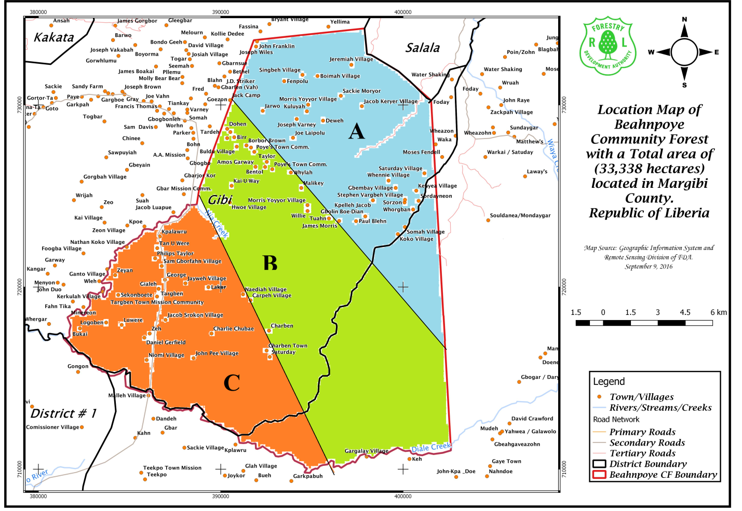

Figure 2: Beahnpoye Community Forest Block Map
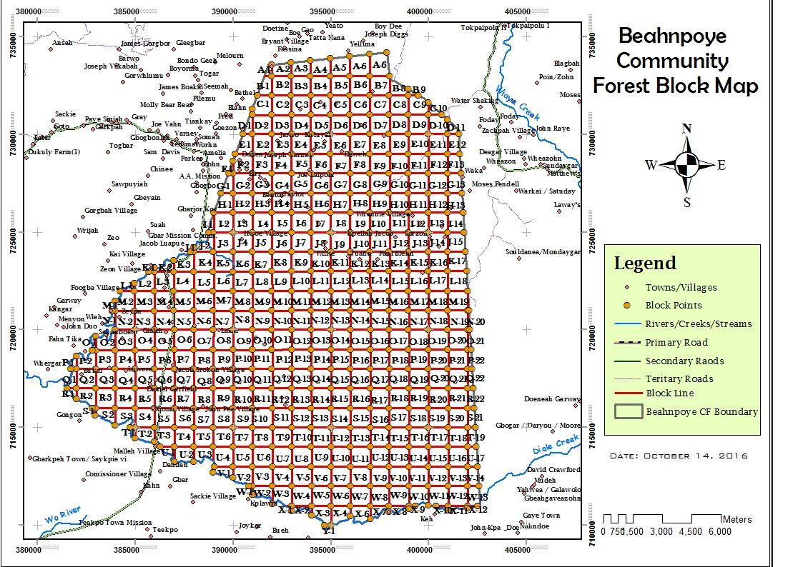

3.0 Assumptions:
- All blocks/survey lines in annual coupe are expected to be operated, all things being equal;
- Harvesting shall be tailored according to market demand;
- The volume expected per hectare may not be the same because the enumerated blocks may contain different volumes;
- The FOB unit price will vary due to the fact that the contract area contains Class A, Class B, as well as Class C timber species which are expected to be harvested during the 2017/2018 Logging Season;
- All sections of merchantable logs harvested shall be exported in round and sawn timber forms;
4.0 Description of the Annual Coupe Boundary:
This annual coupe is found in compartment 1 of the Beahnpoye Community Forest in Margibi County. It has common boundary with the proposed second annual coupe of compartment 1 within the community forest. The Annual coupe contains a surface area of 2,222.52 ha. Also in the annual coupe area, there are some settlements; notwithstanding, over the years extraction of NTFP, hunting and shifting cultivation have been carried out by the community dwellers. Information gathered indicates that in the past, concessionaire operated the forest.

Figure 3: Annual Coupe Map
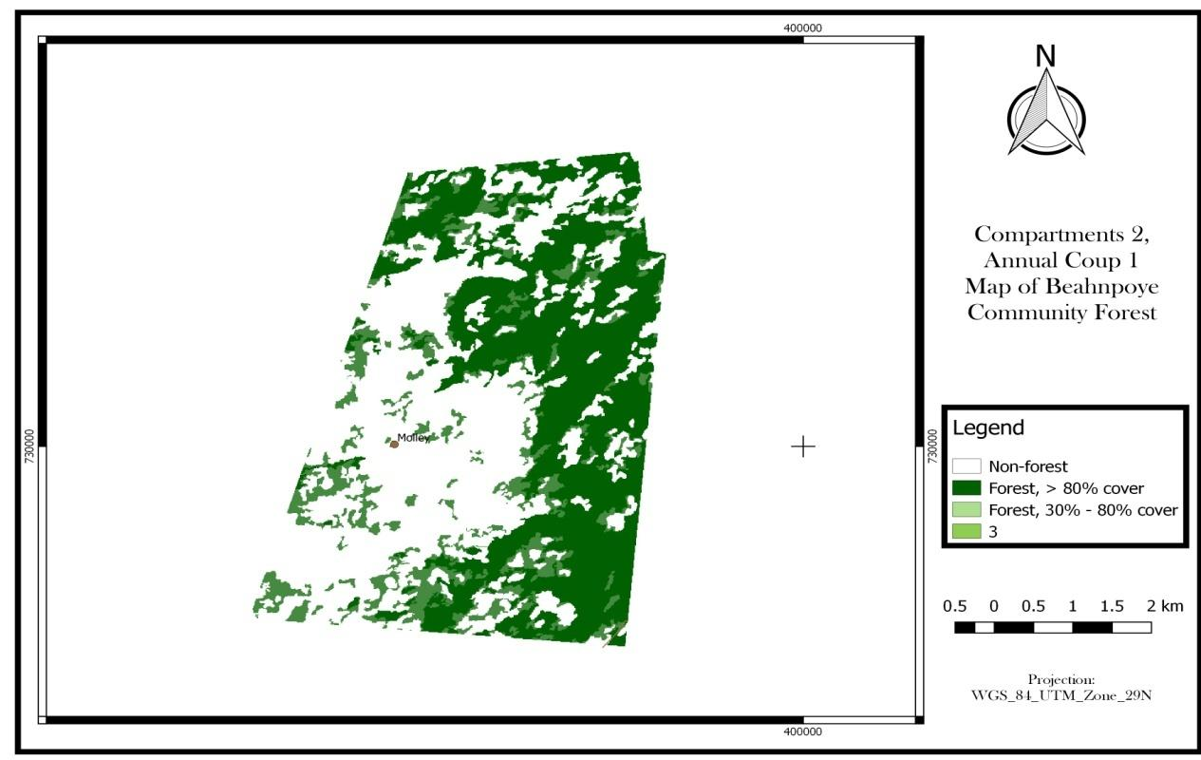

5.0 Metes and Bounds/Technical DESCRIPTION OFTHE COMMUNITY Forest Land

Commencing at a point (388686 724545) on the Nia Creek; thence a line runs N 6° E for 966 meters to a point (388821 725410); thence a line runs N 19° E for 8,851 meters to a point (391812 733554); thence a line runs N 84° E for 6,115 meters to a point (397884 734200); thence a line runs S 6° E for 1,448 meters to a point (398024 732788); thence a line runs S 82° E for 322 meters to a point (398253 732745); thence a line runs S 59° E for 1,770 meters to a point (399754 731846); thence a line runs S 48° E for 2,414 meters to a point (401539 730243); thence a line runs S 3° E for 19,473 meters to a point (402626 711030) on the Diale Creek; thence a line runs Northward along said Creek for 29,292 meters to the confluence of the Nia Creek; thence a line runs Northward along said Creek for 15, 722 meters to the point of commencement, embracing a total of 33,338 hectares / 82,379 acres and NO MORE.

The table below gives a summary of land cover type; the calculation done by GIS technicians put 80% of the annual coupe to be harvestable area while 20%, non – harvestable area. See table.

Table B: Summary of Land Cover
Land Cover Type | Surface Area (hectare) | % of total Area
Actual Harvestable Area | 10,668.1 | 80%
Exclusion Area | 444.5 | 20%
Total hectare/ compartment | 11,112.6 | 100%

Figure 4 : BEAHNPOYE COMMUNITY VEGETATION MAP

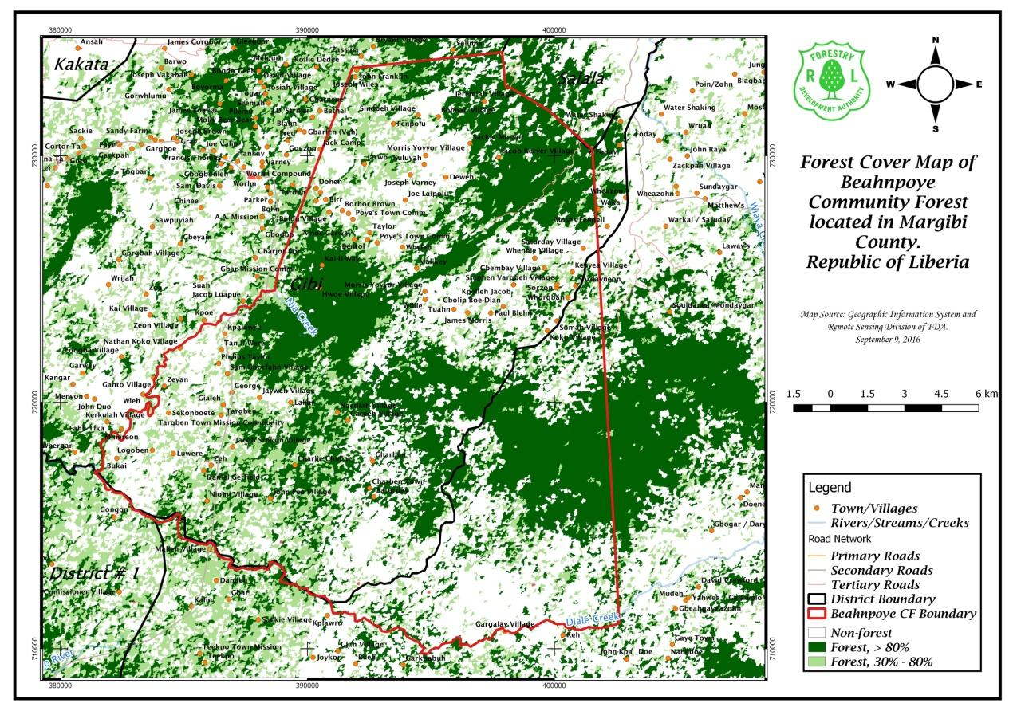

6.0 Management units within the annual coupe
At present, the management units comprise of estimated production/harvestable area, but exclude areas such as watercourses, villages, animal habitats and other exclusion zones.

7.0 Pre- harvest Enumeration Results
The Liberia Code of Forest Harvesting Practices makes provision for the methodology to conduct inventory in the annual coupe as indicated below:
- The annual coupe area is divided into km-square blocks to facilitate the work of inventory crews; and
- 100% forest inventory of the blocks with markings, tagging with barcodes and recording of all trees from 50cm DBH and above will be done.

8.0 Criteria for harvestable trees selection

Though 100% inventory was conducted in blocks earmarked for the annual coupe, the following criteria were used in selecting timber trees to be harvested:
- Minimum diameter cut limit (MDCL) of 50cm and above are the required diameter for harvest;
- Bad quality and dead trees may not be felled, depending on the decision of Management. However, dead trees with commercial value will be harvested and extracted;
- Location of trees is considered, especially those located in protected areas or in buffer/exclusion zones or on deep slope;
- Harvesting limit per block will be 30m³.

9.0 Biological situation
- Fauna ( animals)
There is no actual account of the presence of animals in this annual coupe area. However, there exist some forms of animal species in the contact area as observation of the movement of animals is ongoing.

- Population

The demographic of the annual coupe area indicates a gradual increase in population as a result of logging activities in the area. People are beginning to settle in the towns and villages in the area.
- Human locations (villages and settlements)
Many towns and villages are located within and outside of the community forest contract area. Every employee is required to respect the culture and tradition of the community people.

- Infrastructure
The need for infrastructure development within and outside of the community forest contract area is very great. Akewa Group of Companies will strive to assist in providing schools and healthcare facilities, safe drinking water and other basic social services in order to contribute to the improvement of the livelihoods of the affected communities and the workforce of the company.
- Management units within the annual coupe
At present, the management units comprise of estimated production/harvestable area, but exclude areas such as watercourses, villages, animal habitats and other exclusion zones.

10.0 Akewa Group of Companies objectives

The general business objectives of the Corporation shall be but limited to the following:

- To engage in forest product utilization, and logging operations

- To create alternative uses of the tract of land after harvesting of trees; and

- To create employment for about 300 locals of the contract area and surrounding towns and villages when in full operation.

11.0 Contract Duration

The duration of this community forest management contract is 15 years.

12.0 Chain Of Custody System

In keeping with section 13.5 of the National Forestry Reform Law of 2006 and sections (1-35) of FDA Regulation 108-07, the Chain of Custody System will apply during the life and implementation of this contract. The system so established for the tracking of logs, timber and wood products from forest to processing and then to domestic or foreign market shall be managed by Societe Generale de Surveillance (SGS)/LiberTrace as provided for in section 3.2 (3) of the Chain of Custody System Management Contract of 2007.

13.0 Land Rental & Stumpage Tax

Consistent with section 4 of the regulations to the Community Rights Law, the Company shall be charged to pay land rental tax. Additionally, stumpage fee shall be paid consistent with section 5.7 (c) of the National Forestry Reform Law, section 22 (b) of Regulation 107-07 and section 3 of the regulations to the Community Rights Law.

14.0 Other Fees & GOL Taxes
All other fees and GOL taxes levied on the contracts shall be consistent with the Revenue Law of Liberia and relevant FDA Regulations.
In other words, Akewa Group of Companies will be responsible
- For the payment of all taxes, stumpage, export and contract fees; and
- All other obligations to the affected communities in keeping with the social agreement.

15.0 Duty of Care

The Company shall maintain environmental quality of the cutting area and comply with other conditions consistent with the Liberia Code of Forest Harvesting Practices to include:
- Water course protection
- Erosion prevention
- Prevention of pollution of rivers, streams and other waterways by disposal of wastes
- Prevention of fire disaster

The operation shall also be in conformity with international conventions to which Liberia is a party. They include: the Convention on Biodiversity, the International Tropical Timber Agreement, The United Nations Framework Convention on Climate Change, the Unite Nations Convention to Combat Desertification, the Convention on International Trade in Endangered Species and the RAMSAR Convention on Wetland Management.

16.0 Labor Requirements
Recruitment and employment by the company is consistent with the Labor Laws of Liberia and International Labor Organization.
The Management of AGC shall have a workforce of 250 employees. The initial employment in the starting years will be 150 employees. The employment will take into consideration local and expatriate employees.

Table C: Detail workforce for each sector of logging operations.
POSITION | EXPATRIATE | LIBERIAN | TOTAL | REMARKS
Managing Director | 1 | 0 | 1 | Overall Boss
Senior Manager | 2 | 4 | 6 | Managers
Junior Manager | - | 6 | 6 | Overseers, Supervisors
Officers | - | 6 | 6 | Housing, Maintenance, Sawmilling, Medical staff, etc.
General Workforce | 0 | 131 | 131 | Mechanics, Drivers, Chainsaw operators, Cleaners
TOTAL | 3 | 147 | 150

17.0 Logging Equipment and Machinery

In an effort to promoting reduced impact logging (RIL), wood processing and sustainable forest management, the Company has procured the required equipment and machinery for use during its logging activities as indicated in the below table

Table D: Equipment and Machinery
DESCRIPTION | QUANTITY
Cat D-7 Bulldozer | 3
Cat 120 Motor Grader | 1
966 Front-End Loader | 3
Cat 528 | 3
Electric Generator | 3
Chainsaw | 12
Load Bed trailer | 2
Fuel Tanker | 1
4-wheel drive jeep | 2
Pickup | 6
Land Cruiser Jeep | 1
Log Trucks with Trailers | 14
Dump Trucks | 1

18.0 Conclusion

This Annual Operation Plan is the first of others that Akewa Group of Companies Management will produce in fulfillment of contract obligation. The Plan serves as a guide during the first year of logging operations.
The Company will ensure that local community dwellers are consulted in good faith in order to obtain their free and informed inputs in keeping with the Social Agreement regarding developmental projects in their areas.

AGC contribute to improving the livelihoods of the inhabitants in and around the contract area. The company will strive to provide some basic social services, such as clinics, school, farm-to-market roads, safe drinking water and sanitation facilities for the benefit of the workers, affected communities and the country as a whole.

This AOP will be updated at the end of the first year of operation.

