**FEDERALISM AND THE RECOGNITION OF INDIGENOUS RIGHTS TO LAND AND NATURAL RESOURCES IN MYANMAR: CASE STUDIES FROM CANADA, ETHIOPIA AND BRAZIL**

JANUARY 2020

| By Gabrielle Kissinger |



**Table of Contents**

**EXECUTIVE SUMMARY ……………………………………………………………………………………………………………… 3**

**1. INTRODUCTION …………………………………………………………………………………………………………….. 10**

**2. CANADA …………………………………………………………………………………………………………………… 11**

**3. ETHIOPIA …………………………………………………………………………………………..………………………. 20**

**4. BRAZIL ……………………………………………………………………………………..……………………………. 24**

**5. HOW DO THESE EXPERIENCES PERTAIN TO SIMILAR CHALLENGES IN MYANMAR’S CONTEXT? … 27**

**6. REFERENCES …………………………………..…………………………………………………………..………………….. 35**

**7. APPENDICES …………………………………………………………………………………………..………………………. 38**

**Executive Summary**

This report explores what indigenous and customary rights have been allowed and recognized in three countries that have federal systems of government and also have extensive indigenous communities and groups—Canada, Ethiopia and Brazil. The major focus of this brief is on Canada, as that will be the focus of an indigenous exchange occurring in October/November 2019. The purpose is to explore how indigenous rights have been recognized in Constitutions at federal and state levels, and how this has been affirmed (or not) through case law, legislation and regulation, and land use planning. The purpose of the brief is to explore these contexts, and highlight lessons learned in these contexts that can be useful in the Myanmar context as parties to the 21st Century Panglong Peace process explore solutions to land, natural resources and division of powers in an emerging federal system.

As of September 2019, the national peace process in Myanmar has included little discussion of issues related to natural resource governance (Woods, 2019). Of the 15 existing bilateral ceasefires in Myanmar, only five address natural resources, and rather than reform their governance, the ceasefire agreements simply allow Ethnic Armed Organizations (EAOs) to continue resource exploitation and revenue generation, while maintaining centralized Union government control. The current system of federalism in Myanmar gives very little authority to states/regions, and is silent on how a ‘third tier’ of governance and decision-making (e.g. ethnic governance) will be recognized in this system.

***Canada***

The British Crown and Canadian governments signed treaties with the native people in Canada, as settlement moved westward in the 1800’s and early 1900’s. However, treaties were never signed in most of British Columbia, and these are recognized as unceeded Aboriginal traditional territories. Canada’s government policy and laws normalized a practice of not considering the rights and realities of Indigenous peoples, and forced them to adhere to the culture of the dominant society through ‘residential schools’ and banning aspects of culture and ceremony. Traditional forms of governance and culture were illegal, and the main policy of assimilation was the *Indian Act of 1876*, which still largely governs the relationship between indigenous people and Canada today across most of the country. Over many years the government’s inability to resolve long-standing disputes with Indigenous peoples, and the growing strength among Indigenous peoples and their political organizations calling for reconciliation, resulted in a shift. The *Constitution Act of 1982* recognized and affirmed the existing Aboriginal and treaty rights of Indigenous peoples in Section 35. This Constitutional recognition has formed the legal basis for subsequent claims by indigenous people to uphold their Aboriginal title rights in their traditional territories.

Though there was intent to go beyond this in 1992 with the Charlottetown Accord, which would have allowed Aboriginal governments their own order of government, constitutionally autonomous from the federal and provincial levels of government, it lost in public referendum. Since the 1980s, it has been up to the Courts to determine the extent of the rights mentioned in section 35 of the *Constitution Act of 1982*, based on court cases lodged by First Nations. In 2004 and 2005, the Canadian Supreme Court released a trilogy of decisions that finally affirmed the fundamental notion of the duty to consult with First Nations on decisions that affect their Aboriginal rights, consisting of *Haida Nation v. British Columbia (Minister of Forests) (Haida Nation); Taku River Tlingit First Nation v. British Columbia (Project Assessment Director); and Mikisew Cree First Nation v. Canada (Minister of Canadian Heritage).* These court rulings established procedural protections for Aboriginal and treaty rights, clarified the basis for the Crown’s duty to consult, and outlined a general framework for its implementation. The landmark case of the trilogy is the unanimous judgment in *Haida Nation*, in which the Supreme Court established that the Crown (both Provincial and Federal levels) has a duty to consult Indigenous peoples when it intends to act in a manner that may adversely affect potential or established Aboriginal or treaty rights.

Various processes are occurring to define Aboriginal rights, and they have varying degrees of recognition of indigenous authority as decision-makers on their traditional lands. Treaty negotiations are on-going with many First Nations in British Columbia, are decades-long efforts, and only a handful have reached the fifth and final stage of completion. The Nisga’a Final Agreement is British Columbia’s first modern treaty, which came into effect in 2000, after 113 years of Nisga’a efforts to govern their own lands. Collaborative land use agreements and legal orders have also been pursued, involving government-to-government negotiations between First Nations and the Province. This occurred over 12 years, resulting in the historic Great Bear Rainforest Agreements, finalized in 2016, which redefined land and forest use over 6.4 million hectares (15.8 million acres). Coastal First Nations: The Great Bear Initiative, an indigenous alliance, had formed to assert First Nations leadership in creating a new conservation-based economy in First Nations traditional territories. Their collective ability to negotiate as a government with the province of British Columbia, while also not ceding their Aboriginal rights and title, allowed them to define their land use vision under Provincial law.

The Council of the Haida Nation has pursued coordinated and strategic approaches over 40 years to assert their aboriginal rights and title to their traditional territory on the islands of Haida Gwaii, off the coast of British Columbia. This has been achieved over time, with a mix of approaches including blockades, legal interventions, negotiated land use plans, a co-management arrangement with the federal government, treaty negotiations, acquiring the forest tenure, and persistence and good timing. The Haida Nation’s story is unique in Canada. The Constitution of the Haida Nation, adopted in 2003, mandates the CHN to settle the issue of Aboriginal Title and Rights and ensure that the Haida relationship with their land continues in perpetuity. Haida asserted aboriginal rights and co-management of Gwaii Hanas National Park, and have signed co-management agreements and arrangements that have now run for 25 years. In 2005, the CHN led the protests known as 'Islands Spirit Rising’ which galvanized both Haida and non-Haida residents of the islands around forestry issues, blocked the logging company and Province from destroying heritage forests, and created the context in which a seminal court case defined that the Province had a duty to consult Forest Nations (the Supreme Court of Canada decision in *Haida Nation v. British Columbia (Minister of Forests).* This created a joint, all-Island position which created a context from which positive negotiations with the Province of British Columbia emerged.

The Haida Nation now controls most of the protected areas outside of Gwaii Hanas (the National Park) and controls the majority of logging activity on Haida Gwaii. The Haida obtained the largest forest tenure and created Taan Forest Company, whose shareholders are the Haida citizens, provides economic opportunities while protecting the Nation’s environmental and cultural assets. The Haida Gwaii Strategic Land Use Agreement are legal orders that were approved by the provincial government in 2010, and have set land use objectives. In 2011, the Haida Nation and the Province of BC signed a *Reconciliation Protocol agreement* to create a more productive relationship through a joint decision-making process, resulting in a more respectful approach to land and natural resource management on Haida Gwaii. The Protocol confirms an incremental step in a process of reconciliation of Haida and Crown titles. The agreement created the Haida Gwaii Management Council, which has the authority to make joint determinations related a specific set of strategic land and resource decision types and resource decision types. The Haida Gwaii management council was convened in 2011 and became the decision-making body for land use objectives on Haida Gwaii.

The 2014 Supreme Court decision *Tsilhqot'in Nation v. British Columbia* set a new precedent when the Court determined that the Province of British Columbia breached its duty to consult with the Tsilhqot’in First Nation, and a declaration of Aboriginal title over the area requested should be granted. This may usher in a new era of recognition of Aboriginal title and rights. What must be determined now is what laws will apply to the Aboriginal title lands, and these are likely to be a combination of Tsilhqot’in First Nations law, provincial and federal laws, in accordance with the constitutional division of powers and the rules of federalism, as they are evolving. In 2018, the Government of Canada began a process to reform its laws and policies to ensure the rights of Indigenous peoples, and the treaties and agreements the government has signed are upheld, through a ‘Recognition and Implementation of Indigenous Rights Framework.’

## ***Ethiopia***

Since the Ethiopian People’s Revolutionary Democratic Front (EPRDF), came to power in 1991 and introduced the concept of ethnic self-determination, Ethiopia has transitioned from suffering from large-scale conflicts between a centralized state and ethnically based liberation fronts to more stability, though problems have been escalating. The 1994 Constitution granted the right of nationalities to self-determination, and established states based on majority ethnic divisions. However, the process lost some legitimacy as it was viewed as being politicly driven by the EPRDF. Non-native ethnic minorities live within every ethnic homeland, creating ‘endless minorities.’ Ethnic militias are increasingly mobilizing, with conflicts between neighboring ethnic states, and in conflicts between native and non-native groups. The strife since 2014 is largely attributed to unresolved questions of land and territory under ethnic federalism, based on the delineation of ethno-regional borders and the prioritization of land access for the indigenous populations and outside investors (especially agribusiness). However, pastoralists and shifting cultivators have lost land access to outside investors, and ethnic minorities have been displaced due to growing resource shortages.

Ethiopia’s governance consolidates significant power and authority with central government, including formulating and implementing the country’s policies, strategies and plans in economic, social and development matters, conservation of land and other natural resources, and so on. The states therefore administer land and other natural resources in accordance with Federal laws, and they can also levy and collect taxes and duties on revenue sources reserved to the States.

Despite the 1994 Constitutional intent to allow for ethnic self-determination, Ethiopia maintained the Derg land regime, which had nationalized all rural land in 1975, to destroy the feudal landholding class, but then consolidated land ownership authority with the central government. Further, central government authority over rural land was administered by Peasant Associations, which have the role of distributing land access rights, which positioned them as instruments of control rather than allowing ethnic governance systems to develop and promote self-administration. This decentralized corruption, and disempowered sub-national decision-making. It also created a contradiction between Ethiopia’s land policy, which gives smallholder farmers equal access rights to land, and the principles of ethnic federalism.

The locus of authority, territorial jurisdiction and principle of citizenship differ between the concept of state ownership, ethnic federalism, and neo-customary tenure systems. Despite the central governments assertion of their right over land, neo-customary tenure systems are followed in many parts of the country. In these systems, clan elders are responsible for decisions. Local citizenship is based on the clan, with excludes non-indigenous ethnic people, as well as other indigenous clans. This contrast with federalism, which provides equal rights for all those from the dominant ethnic group of the region. Ethiopia’s experience highlights the limitations of federalism as an institutional construct to address ethnic challenges. The experience highlights the importance of carefully constructing institutional designs that promote the principles of shared rule and inclusivity in the most contested political space and at all levels of government.

## ***Brazil***

*Terra Indígena* or indigenous lands comprise about 13% of Brazil’s land area, and 98% are in the Amazon forest biome. Brazil’s relationship with its indigenous population has been forged through often violent colonization of remote forest areas, as settlement expanded from the more populated coastal areas. Yet, the 1988 Constitution of Brazil took a bold step forward, recognizing that, “Indians shall have their original rights to the lands they traditionally occupy, it being incumbent upon the Union to demarcate them, protect and ensure respect for all of their property (Article 231).” The term “*originários*” contained in Article 231 of the Constitution, reflects the oldest and most powerful land tenure right under Brazilian law. Though this provides a framework for overarching indigenous principles and rights, it relies on other pieces of legislation enacted by the government to identify the finer details of implementing these rights. However, these pieces of legislation have not yet been fully enacted, which has resulted in the *Indian Statute of 1973* (Law 6001/73) still having a role, though it largely contradicts the rights given to indigenous peoples in the 1988 Constitution, and has treated indigenous peoples as wards of the state (under the functions of FUNAI). The Brazilian Policy for Territorial and Environmental Management of Indigenous Lands (PNGATI) was established in 2012 (Presidential Decree no. 7,747 of June 5, 2012), with the objective of ensuring and promoting the protection, recovery, conservation and sustainable use of natural resources in indigenous territories and lands, and was a major step forward to create territorial and environmental management plans in indigenous areas.

The demarcation process by FUNAI, which is required for a *Terra Indígena* to be recognized, is only about half completed, 26 years after their initial due-date. They have been subject to legal battles, and these areas are frequently subject to illegal invasions by settlers, mining and logging companies. This points to the challenges to recognize the uniqueness of this land designation and associated rights under the Constitution of 1988.

The role of the courts to uphold constitutional rights has been weak, and the The “Raposa Serra do Sol” ruling, which set a legal precedent on land demarcation and indigenous rights, has not been enough to resolve the multitude of land conflicts. In fact, it has strengthened the assertion that indigenous lands are the national government’s property and they can be given usufruct rights. The lack of real devolution of power and self-governance to TI’s, lack of a legislative framework to respect the TI’s, which could define a basis for enforcement, and the influence exerted by the congressional rural caucus, which represents the interests of the agricultural and livestock businesses, had dramatically undermined indigenous rights. This raises serious questions about the extent of indigenous rights under the 1988 Constitution, and the current political climate will only deepen the polarity.

## ***How these experiences relate to Myanmar***

The experiences in Canada, Ethiopia and Brazil illustrate how federalism, as an institutional governance device, is not enough to respond to the challenges of ethnic diversity. Despite the Constitutional commitments to indigenous rights, in all three countries this has not worked out as planned for in Constitutions. In Canada and Brazil, though the Constitution recognized existing aboriginal/indigenous rights, it did not demarcate where this was to occur (though in Brazil, half have now been demarcated), what laws would apply in these areas (though in Brazil, the PGGATI law of 2012 was intended to guide the implementation of Chapter 231 of the Constitution), and how those laws or procedures would relate to the rest of the federal system. Leaving it to the courts to interpret and decide constitutional intent on indigenous rights can be a quagmire. In Ethiopia, prioritizing the main indigenous populations in ethnic states created endless minorities, which only exacerbated ethnic conflicts, and an over-reliance on ethnic identity, at the cost of a uniting federal identity. In all contexts, maintaining strong central (in Brazil and Ethiopia) or provincial (in Canada) government control, has worked against meaningful devolution of powers and authority, and this is most notable in the land and the natural resource sectors. In all of these contexts, land is the central basis of aboriginal/indigenous rights, and without adequate recognition of rights of self-governance in indigenous lands, conflicts continue to flare.

In Canada and Brazil, the *Indian Act* and *Indian Statute*, respectively, defined a relationship in which Indigenous were essentially made wards of the state, with the central government as trustee. The result in both countries has been disastrous for indigenous people in these systems. In both contexts, these policies and modes of relationships between colonial governments and their indigenous populations, which preceded their constitutions, are difficult to undo unless the country’s legislative system is overhauled to reflect the change. This has not happened yet in these countries. Customary land rights have not adequately been defined in these systems. When it comes to land, consideration must be given to the locus of authority, territorial jurisdiction and principles of citizenship, and how they differ between layers of governance. As the experience in Ethiopia shows, decentralization of administration (but lacking authority) to more localized power structures, under centralized control, can lead to corruption and new destabilizing power dynamics, such as customary and traditional power structures being co-opted to exert federal control locally.

Indigenous culture is fundamentally tied to land, so defining land rights in the same section as Indigenous rights in a Constitutional setting makes clear this connection. In Myanmar, the Constitution of 2008 does not contain such recognition. Myanmar’s current *Constitution* (of 2008, additional amendments in 2015) does not meaningfully devolve decision-making authority on land and natural resources to state/regions, or third-tier entities. That means in practice that all authority continues to be held with the Union government. The UPDJC peace process seeks to find reconciliation between Union government and ethnic nationalities. As such, the National Ceasefire Agreement (NCA) and bi-lateral cease-fire agreements are the largest point of leverage that ethnic armed organizations have. *Including land and natural resources in these important agreements is crucial, to signal their importance in the solution set towards peace.* However, the NCA only includes two clauses related to land and natural resources: 1) avoiding forcible land confiscation in favor of land tenure security (§9), and 2) supporting environmental conservation and community consultation in the planning of projects impacting civilians in ceasefire areas (§25). These provisions do not signal recognition of indigenous rights and title to their lands, in a federal system, but only reinforce Union government control and authority over ethnic lands. In contrast, in Canada, treaties and protocol agreements have centered on land and natural resources, as a basis point for reconciling authority and autonomy in a federal system.

As such the following can be a basis for considering the different aspects of authority and territorial jurisdiction (including the recognition of rights) and how that sits in relation to land designation options that allow indigenous people to define their traditional territory and related decision-making authority within a federal system containing a majority of public lands (as opposed to private lands). The range of **engagement options for central and state/regional government** to recognize indigenous rights to land in a federal system in the above case studies, in order from giving least authority to most authority to indigenous governance bodies or regimes is shown in the Figure below:

This sits in relation to the range of **land designation options that allow indigenous people to define their traditional territory and related decision-making authority and responsibility** in the above case studies, for central and state/regional government to recognize indigenous rights to land. These are listed in order from giving least authority to most authority to indigenous governance bodies (see Figure below):

*Source: Author*

**Figure 7: Range of engagement options for federal and state government with indigenous people**

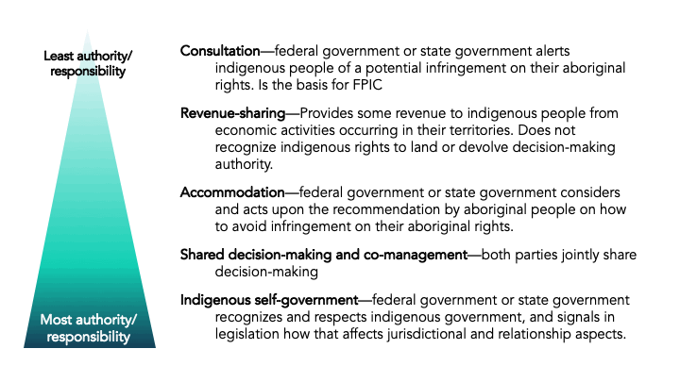

**Figure 8: Range of land designation options that allow indigenous people to define their traditional territory and related decision-making authority and responsibility**

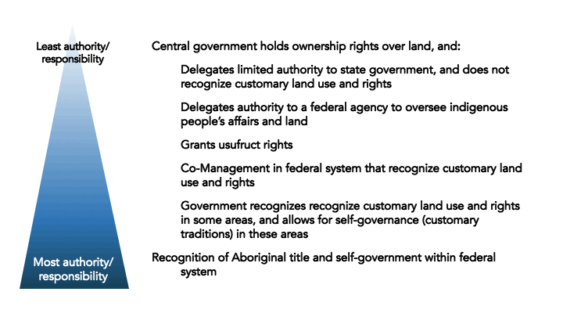

*Source: Author*

EAOs are setting up systems and departments to govern and administer territories, land and resources, and populations in their traditional territories. The KNU, KIO, NMSP, and Karenni National Progressive Party (KNPP) have pursued such steps. These generally recognize and complement customary management practices, and provide culturally appropriate service provision, such as health care and education. Several EAOs also have forestry and agriculture departments that manage land and natural resources under their territorial jurisdiction. NCA-signatory and non-signatory EAOs have updated and revised policies related to land, environment and natural resources (Woods, 2019).

The Myanmar ICCA Working Group is convening a network of Indigenous Community Conservation Areas (ICCAs) in EAO areas, which are bottom-up approaches to document and strengthen customary and indigenous areas, protect these areas from land grabs and environmental destruction, secure appropriate legal protection, and promote the ICCA as an alternative to top-down conservation and land management. ICCA groups have formed in Tanintharyi, Bago, Magwe and Sagaing Regions, and Karen, Shan, Chin and Kachin States. ICCA areas can be compatible with EAO land, forest and natural resource policies.

*A joint agreement under the UPDJC, or further refinement of Interim Arrangements under the NCA, could be further expanded upon to define the processes by which reconciliation of ethnic people’s indigenous right to their land and natural resources can be pursued*. It would be useful to explore how current ceasefire agreements and federal institution-building could ‘do not harm’ to ethnic indigenous rights, and hold the space to further define what this might look like, in a federal system that preserved the Union, while granting more autonomy to ethnic governance systems. That would include recognition of ethnic rights to land in their traditional territories, and their inherent rights to govern (in particular, recognizing traditional forms of governance), to make and enforce their laws, and to manage their lands, resources and institutions. With that as a basis point, it becomes clearer how to define steps that could be taken to build trust between different levels of government in an emerging federal system.

**1. Introduction**

This report explores what indigenous and customary rights have been allowed and recognized in three countries that have federal systems of government and also have extensive indigenous communities and groups—Canada, Ethiopia and Brazil. The major focus of this brief is on Canada, as that will be the focus of an indigenous exchange occurring in October/November 2019. The purpose is to explore how indigenous rights have been recognized in Constitutions at federal and state levels, and how this has been affirmed (or not) through case law, legislation and regulation, and land use planning. The purpose of the brief is to explore these contexts, and highlight lessons learned in these contexts that can be useful in the Myanmar context as parties to the 21st Century Panglong Peace process explore solutions to land, natural resources and division of powers in an emerging federal system.

Myanmar is in a process of defining its federal system, after 70 years of military rule. Therefore, exploring lessons learned in other jurisdictions that have a similar set of issues can be useful to all parties that are seeking a democratic and federal system of government in Myanmar, which respects its ethnic people. As of September 2019, the national peace process in Myanmar has included little discussion of issues related to natural resource governance (Woods, 2019). Of the 15 existing bilateral ceasefires in Myanmar, only five address natural resources, and rather than reform their governance, the ceasefire agreements simply allow Ethnic Armed Organizations (EAOs) to continue resource exploitation and revenue generation, while maintaining centralized Union government control (ibid). The Nationwide Ceasefire Agreement (NCA) only includes three clauses related to land and natural resources: 1) avoiding forcible land confiscation in favor of land tenure security (§9), and to carry out in coordination, during the interim period: 1) environmental conservation (§25(a)2) and 2) planning of projects that may have a major impact on civilians living in ceasefire areas shall be undertaken in consultation with local communities in accordance with the Extractive Industries Transparency Initiative (EITI) Standard procedures and coordinated with EAOs for implementation (§25(b)). The EITI Standard is about transparency and accountability of extractive industries and the related public burden. While a very important mechanism, it’s multi-stakeholder group function should not replace the diligence and rigour of free prior informed consent (FPIC) of people in the vicinity of projects. Thus, the NCA does not contain the consultative provisions that would allow local ethnic people a say in resource extraction in their territories. And even that is still a far from proactive governance of ethnic regions, by ethnic people, with a long-term view for their future.

The current system of federalism in Myanmar gives very little authority to states/regions, and is silent on how a ‘third tier’ of governance and decision-making (e.g. ethnic governance) will be recognized in this system. Myanmar’s current Constitution (of 2008, additional amendments in 2015) does not devolve decision-making authority on land and natural resources to state/regions, or third-tier entities. The 2015 constitutional amendments allows for states/regions to carry out specific activities, in accordance with laws enacted by the Union government. States/regions can carry out reclamation of vacant, fallow and virgin lands, but overall authority and title is still held by the Union government. The licensing and collection of certain revenue streams are allowed from artisanal and small-scale mining activity, salt, land revenue, agriculture, freshwater fisheries, smaller-scale electricity generation and traditional medicines is allowed. States/regions have the right to legislate forest laws related to village firewood plantations and timber that is not marked as “State (e.g. Union government)” species (which excludes all Myanmar’s revenue-producing species of teak and thityar, ingyin, pyingadoe, padauk, thingannet and tamalan). Tax can be collected on non-timber forest products and those timber species not reserved by the State (Republic of the Union of Myanmar, 2015). Though states/regions have the authority to collect 19 types of taxes and fees, to date they largely continue to rely on fiscal transfers from the Union government (a mix of shared revenues and grant transfers) to fund their activities, and the income and expenditures of State and region departments and state economic entities only account for 11 % of all public spending in states and regions (Deshpande, 2018). Self-Administered Divisions and Self-Administered Zones can pass laws, but if any laws are in contravention of the Constitution, Union government, Pyidaungsu Hluttaw, state/region Hluttaw, those will prevail (Republic of the Union of Myanmar, 2008)

However, ethnic leaders argue that federalism should enable ethnic minority populations to have a greater say in their own region’s development. Decentralization can provide a means to provide more financial benefit and decision-making to states/regions and local populations. Much of the focus so far has been on the percentage of revenue from natural resources that should be shared. However, many other issues, such as ownership rights and how natural resources are to be governed, should be resolved first. Revenue sharing alone will not achieve the long-term goals of sustained peace, recognition of customary land rights, respecting ethnic traditions and connection to land, and could even undermine debates and pathways to resolving these issues (Woods, 2019).

1. In reviewing different jurisdictions that have grappled with similar challenges, this brief explores the following questions:
2. How are indigenous rights recognized in Constitutions, and in laws and regulations in these contexts?
3. Do the recognition of indigenous rights extend to land? Does it include decision-making authority on indigenous lands and territories?
4. What have been the largest challenges in these federal systems to recognizing indigenous rights to land and natural resources?
5. How do these lessons pertain to Myanmar’s context?

Responding to these questions in the context of Canada, Ethiopia and Brazil, each country section covers, a) general overview of the background on the national and ethnic context, b) what provisions exist in the national constitution, c) what laws exist and what the role of courts has been in recognizing indigenous land rights and title, and d) relevant sub-national legal decisions, policy and practice. The last section of this report explores how these country experiences pertain to similar challenges in Myanmar’s context.

**2. Canada**

***Background***

Aboriginal people in Canada are highly diverse in their cultures, histories, languages (more than 70 Aboriginal languages were recorded in the 2016 Census) and their connection to land. ‘Aboriginal people’ is defined in the Constitution to include First Nations people, Métis and Inuit. There were 1.67 million Aboriginal people in Canada in 2016, accounting for 4.9% of the total population (Statistics Canada, 2016). Over half of First Nations people live in the western provinces of British Columbia, Alberta, Manitoba, and Saskatchewan.

Canada’s history with Indigenous people was largely defined by the colonial might of settlers over the country’s first inhabitants. Historically, treaties between the Crown and indigenous people occurred between the early 1700s and the 1920s, and most include a land rights “surrender” provision, in exchange for reserves, payments, and the continued right to hunt

and fish in the surrendered areas (Bergner and Jones, 2015). Government policy and laws normalized a practice of not considering the rights and realities of Indigenous peoples, and forcing them to adhere to the culture of the dominant society through residential schools and by banning aspects of culture and ceremony. Traditional forms of governance and culture were illegal, and it was illegal for indigenous people to bring issues of title and rights to the courts until the 1950s (Wilson-Raybould, 2017).

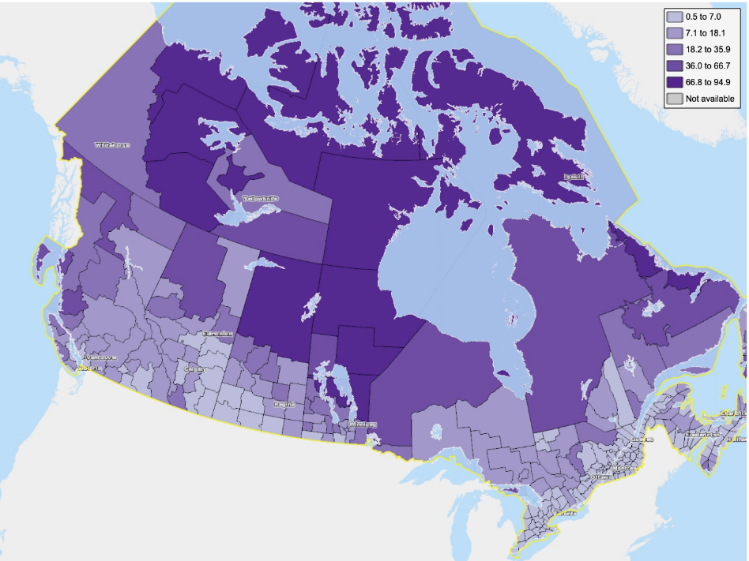The main assimilation policy was the Indian Act of 1876, which still largely governs the relationship between indigenous people and Canada today. Under the Indian Act, Indians were defined and made wards of the state, with the government as trustee. This involved 60 to 80 Nations or Tribes being divided into 633 small federal administrative enclaves called ‘bands’ on about 3,000 reserves. (Wilson-Raybould, 2017).

**Figure 1: Percentage of the population in Canada with Aboriginal identity**

Between 1969 to 1992, the relationship between Indigenous people and Canadian governments saw tumultuous relations between Aboriginal people and Canadian governments. Prime Minister Pierre Trudeau proposed the 1969 White Paper, which sought to incorporate First Nations Peoples fully into provincial government responsibilities as equal Canadian citizens, terminating the federal government's special relationship with Indigenous peoples. A standoff between Mohawk protesters, the police, and army at Kanesatake (the Oka Crisis), over development proposals on disputed land that included a Mohawk burial ground, brought national media coverage. The period ended with the defeat of the Charlottetown Accord, which would have given Aboriginal people the right of self-government (see below), in a Canada-wide referendum. Two broad themes emerged during this era: the inability of governments, through constitutional reform, land claims policy and government programming, to resolve long-standing disputes with Indigenous peoples; and the gathering strength of Indigenous peoples and their political organizations to respond to this failure (Royal Commission on Aboriginal Peoples, 1996).

*Source: Statistics Canada, based on 2016 Data*

***Constitution***

Canada’s Constitution of 1867 was revised in 1982, and those revisions contain Aboriginal rights. Aboriginal people in Canada are defined as First Nations, Inuit, and Métis), and Section 35 recognizes and affirms the existing Aboriginal and treaty rights of Indigenous peoples (Government of Canada, 1982) (refer to Annex 1a). This is the Section of the Constitution that subsequent court cases have referenced, and it is this section which has upheld Aboriginal rights.

The 1982 Constitutional revisions also contain the Canadian Charter of Rights and Freedoms. The Charter contains a provision for equality under law and equal protection, and also ensures that Aboriginal rights are not impacted through the Charter (refer to Annex 1b). However, the Charter makes clear in Section 1 that the rights and freedoms guaranteed by the Charter are subject to reasonable limits, they are not absolute, and they may be limited in order to protect the interests of Canadian society as a whole. Respect for Canada's ethnic minorities and multicultural heritage is defined in Section 27 of the Charter (Government of Canada, 1982b). Canada’s multiculturalism and commitment to ethnic diversity was originally rooted in how the relationship was defined between Canada and the Canadian province of Quebec, which sought to protect the cultural distinction of francophone Quebecois. It has since expanded to better reflect Canada's support for the increasing multi-cultural diversity of the country, especially in urban areas.

Canada’s Constitution (spanning 1867-1982) makes clear that when it comes to land, the Parliament of Canada has legislative authority over ‘Indians and land reserved for the Indians,’ and that Provincial Legislatures have authority over ‘the management and sale of the Public Lands belonging to the Province and of the Timber and Wood thereon.’ Further, Section 92 on the powers of Provinces provides for full jurisdiction by the provincial legislature to make laws in relation to: a) exploration for non-renewable natural resources in the province; b) development, conservation and management of non-renewable natural resources and forestry resources in the province, including laws in relation to the rate of primary production; and c) development, conservation and management of sites and facilities in the province for the generation and production of electrical energy (Government of Canada, 1982a).

Though defeated in a public referendum, the Charlottetown Accord would have amended the Constitution in 1992 to, “recognize that the Aboriginal peoples of Canada have the inherent right of self-government within Canada. This right should be placed in a new section of the Constitution Act, 1982, section 35.1(1). The recognition of the inherent right of self-government should be interpreted in light of the recognition of Aboriginal governments as one of three orders of government in Canada (Parliament of Canada, 1992).” This means the Constitutional change would have granted Aboriginal governments their own order of government, constitutionally autonomous from the federal and provincial levels of government. Aboriginal legislation could, “not be inconsistent with those laws which are essential to the preservation of peace, order and good government in Canada.” A constitutional provision would ensure that federal and provincial laws would continue to apply until they are displaced by laws passed by governments of Aboriginal peoples pursuant to their authority. The inherent right of self-government would have allowed their, “authority of the duly constituted legislative bodies of the Aboriginal peoples, each within its own jurisdiction: a) to safeguard and develop their languages, cultures, economies, identities, institutions and traditions; and, b) to develop, maintain and strengthen their relationship with their lands, waters and environment, so as to determine and control their developments as peoples according to their own values and priorities and ensure the integrity of their societies (ibid).” The Accord defined that a process of negotiations for questions related to land to be included in Aboriginal self-government agreements, “including issues of jurisdiction, lands and resources, and economic and fiscal arrangements (ibid).” There are many theories as to why voters rejected the Accord (losing 55% to 45%). Quebec separatists felt the accord did not go far enough, and some feared disintegration of the Federal government. Prime Minister Brian Mulroney's growing unpopularity during a period of economic strain, and discontent by western state conservatives also contributed to its failure.

***Laws and the role of courts in recognizing indigenous land rights and title***

It has been up to the Courts to determine the extent of the rights mentioned in section 35 of the Constitution Act of 1982. Prior to 2004/05, consultation considerations were limited to cases of infringement on established section 35 rights. Then, in 2004 and 2005, the Supreme Court released a trilogy of decisions that finally affirmed the fundamental notion of the duty to consult, consisting of Haida Nation v. British Columbia (Minister of Forests) (Haida Nation); Taku River Tlingit First Nation v. British Columbia (Project Assessment Director); and Mikisew Cree First Nation v. Canada (Minister of Canadian Heritage). These court rulings established procedural protections for Aboriginal and treaty rights, clarified the basis for the Crown’s duty to consult, and outlined a general framework for its implementation. The landmark case of the trilogy is the unanimous judgment in Haida Nation, in which the Supreme Court established that the Crown has a duty to consult Indigenous peoples when it intends to act in a manner that may adversely affect potential or established Aboriginal or treaty rights (Brideau, 2019).

In other words, federal and provincial governance institutions have not proactively promoted reconciliation with Aboriginal people. The following cases (among others) have protected Aboriginal rights and title, duty to consult, duty to accommodate, but also raise awareness of the fragility of the Constitutional Aboriginal rights:

1. In 2014, the Supreme Court of Canada issued an unprecedented decision on indigenous land rights in the case Tsilhqot'in Nation v. British Columbia, 2014 SCC 44.[1] The case started in 1983, when the province of British Columbia granted a commercial logging licence on land considered by the Tsilhqot’in to be part of their traditional territory. The band objected to and sought a declaration prohibiting commercial logging on the land. The Court determined, based on tests to justify the province’s incursions on Aboriginal title, that the issuance of timber licenses on Aboriginal title land was a direct transfer of Aboriginal property rights to a third party, which is a meaningful diminution in the Aboriginal group’s ownership right, and was done without Aboriginal consent. The Court held that, “Aboriginal title constitutes a beneficial interest in the land, the underlying control of which is retained by the Crown.” Further, that, “rights conferred by Aboriginal title include the right to decide how the land will be used; to enjoy, occupy and possess the land; and to proactively use and manage the land, including its natural resources (Supreme Court of Canada, 2014).” The Court determined a declaration of Aboriginal title over the area requested should be granted, and that the Province of British Columbia breached its duty to consult with the Tsilhqot’in.
2. The Supreme Court of Canada confirmed in Haida Nation v. British Columbia (Minister of Forests) that both the provincial and the federal Crowns (e.g., government) owe First Nations a legal duty of meaningful consultation in respect of Crown decisions that could affect Aboriginal rights, including Aboriginal title. The Minister of Forests allowed the transfer of "Tree Farm License (TFL) 39" from one firm to another, prompting Haida to renew their objections to the license's coverage on Haida Gwaii, which had not been titled to them in any treaty, but to which they laid claim for more than 100 years. The decision found, “Canada’s Aboriginal peoples were here when Europeans came, and were never conquered. Many bands reconciled their claims with the sovereignty of the Crown through negotiated treaties. Others, notably in British Columbia, have yet to do so. The potential rights embedded in these claims are protected by s. 35 of the Constitution Act, 1982. The honor of the Crown requires that these rights be determined, recognized and respected. This, in turn, requires the Crown, acting honorably, to participate in processes of negotiation. While this process continues, the honor of the Crown may require it to consult and, where indicated, accommodate Aboriginal interests (Supreme Court of Canada, 2004). Further, the duty to consult and accommodate is part of ‘reconciliation,’ which, “is a process flowing from rights guaranteed by s. 35(1) of the Constitution Act, 1982. This process of reconciliation flows from the Crown’s duty of honorable dealing toward Aboriginal peoples, which arises in turn from the Crown’s assertion of sovereignty over an Aboriginal people and de facto control of land and resources that were formerly in the control of that people. Further, the court ruled that the forestry company which held the TFL 39 was not obliged to consult with the Haida, as the legal responsibility for consultation and accommodation rests with the Crown, and could not be delegated.
3. The United Nations Declaration on the Rights of Indigenous Peoples, endorsed by Canada in 2010, provides that member states must consult and cooperate with Indigenous peoples on certain matters, such as “legislative or administrative measures that may affect them,” in order to obtain their free, prior and informed consent (Brideau, 2019). However, a 2018 Supreme Court of Canada decision illustrates the supremacy of parliamentary sovereignty over protection of Aboriginal rights and title. In 2012, the Mikisew Cree First Nation brought an application for judicial review in Federal Court, arguing that the Crown had a duty to consult them on the development of omnibus legislation with significant effects on Canada’s environmental protection regime, since it had the potential to adversely affect their treaty rights to hunt, trap, and fish. A Federal Court of Appeal concluded that when ministers develop policy, they act in a legislative capacity and their actions are immune from judicial review, upholding the principles of parliamentary sovereignty, the separation of powers, and parliamentary privilege. The Supreme Court held that the development, passage and enactment of legislation does not trigger the duty to consult with Aboriginal people (Supreme Court of Canada, 2018). **The Court had to reconcile these two constitutional principles, and the outcome of their decision can be useful to consider in the context of Constitution drafting in Myanmar.**

***Sub-national legal decisions, policy and practice***

As Canada’s Constitution mandates that Provincial Legislatures have authority over forest land and forest resources, the duty to consult and reconciliation aspects of the relationship between Provinces and Aboriginal people occurs in various ways in Canadian Provinces. As mentioned in the section above, the duty to consult was only achieved through pressure brought by the Supreme Court. A practice of ‘referrals’ has developed, through which the Province, the federal government, and even development project proponents pursue consultation.[2] While this has been an important step in consultation, it has also put a fair amount of pressure on First Nations to technically respond[3] to development interests in their territory, which is more reactive than proactive (such as defining aboriginal interests, and then obliging development proposals to demonstrate compliance with that). The concept of the Crown accommodating Indigenous interests has been even more challenging. That said, important steps have been taken through treaties and collaborative land use agreements that demonstrate reconciliation and shared decision-making between federal, provincial and territorial, and now re-emerging Indigenous government

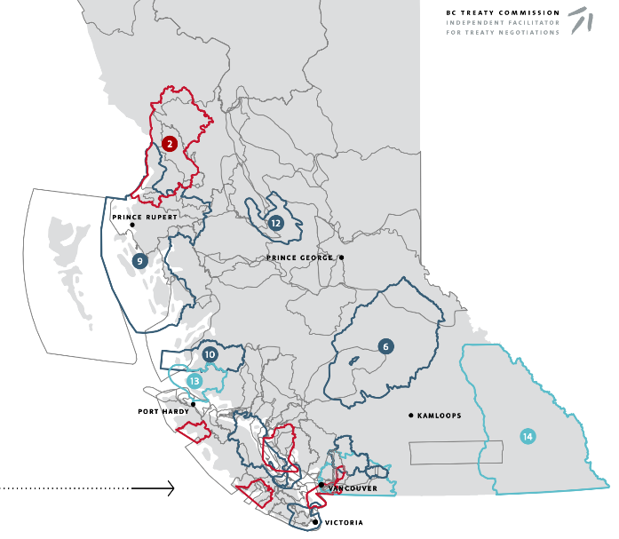**Figure 2: Status of Treaty negotiations in British Columbia, Canada**

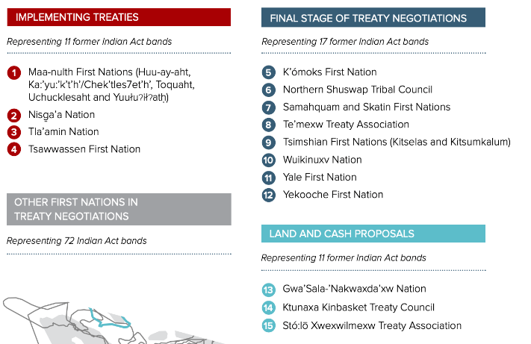

*Source: BC Treaty Commission*

***Treaties***

As Treaties between Aboriginal people and the Crown were never completed in most of British Columbia, these lands are unceeded aboriginal territories, and there is broader scope to assert Aboriginal interests in these areas. The BC Treaty Commission is the independent facilitator for treaty negotiations.[4] There are seven First Nations implementing completed treaties, nine in the final stages of treaty negotiations, three negotiating land and cash proposals, seventeen in active negotiations, and another twenty-seven that are not actively negotiating a treaty (though the majority have reached Stage 4 (out of 5 Stages) of the Treaty process).

The Nisga’a Final Agreement (#2 in Figure 2) is British Columbia’s first modern treaty, which came into effect in 2000, after 113 years of Nisga’a efforts to govern their own lands. The Treaty was the first in British Columbia to provide constitutional certainty of Aboriginal people’s Section 35 rights to self-government, and the authority for the Nisga’a to manage lands and resources over their 499,000 acres of land.[5] When the treaty was adopted, the Nisga’a people ceased to be governed under the Indian Act. The treaty defines which lands and resources are owned by the Nisga’a, and the scope of matters under the exclusive legislative jurisdiction of the Nisga’a Lisims Government or where there may be shared jurisdiction with British Columbia or Canada, including the rules to resolve conflicts. Forests are managed by the Nisga'a Lisims Government Forest Resources Department, to provide employment and to protect their natural heritage.[6]

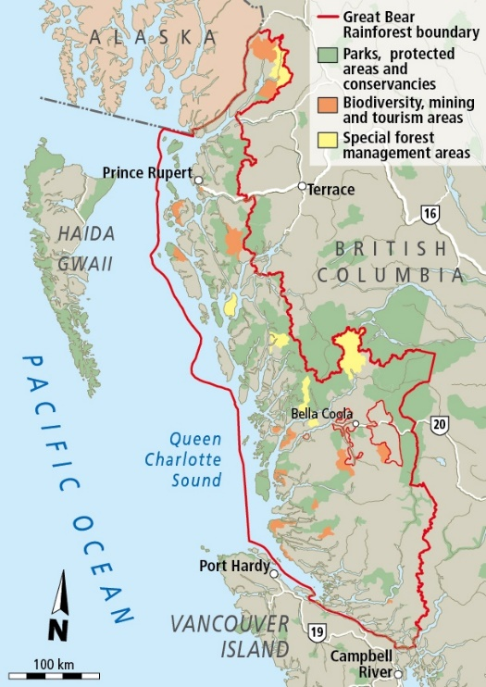***Collaborative land use agreements***

**Figure 3: Great Bear Rainforest**

In the 1990’s, conflicts over the logging of old-growth coastal temperate rainforest in British Columbia precipitated a ‘war in the woods’ between the logging industry, environmentalists and First Nations. In 1992, the BC government initiated a strategic land-use planning process, hoping that common ground could be found, and a comprehensive plan with broad-based support might help resolve the disputes. Most of British Columbia’s land is publicly owned, with unresolved Aboriginal Rights and Title, and commercial forests overlaying First Nations’ traditional territories. First Nations communities on the coast suffered up to 80% unemployment rates, a dwindling forest and fisheries resource base, and lack of power and authority over their traditional lands to change the situation. An indigenous alliance – Coastal First Nations: The Great Bear Initiative[7]—was formed to assert First Nations leadership in creating a new conservation-based economy in First Nations traditional territories, spanning all First Nations willing to join together. In 2002, leaders from BC’s Central and North Coast and Haida Gwaii came together to sign the Declaration of First Nations of the North Pacific Coast, and by 2004 this was a coast-wide alliance. Simultaneously, environmental organizations and the logging industry sought agreements, and the Province underwent North and Central Coast Land and Resource Management Plans, to define ecosystem-based management approaches to change logging practices and establish new protected areas. These draft agreements were agreed upon by the logging industry, environmental organizations and regional stakeholders, and were then brought into government-to-government negotiations between the Province of British Columbia and First Nations (Coastal First Nations and Na̱nwaḵolas Council). This was the first time that First Nations gained the leverage to be recognized as legitimate governments (thus called ‘government-to-government’ negotiations) in Provincial planning processes. The result was the Great Bear Rainforest Agreements which redefined land and forest use over 6.4 million hectares (15.8 million acres).[8] At the same time, C$120 million was raised to support the transition to a conservation economy, with half allocated to a conservation endowment fund would be dedicated solely to conservation management, science and stewardship jobs in First Nations communities, and the other half (which were public funds) would be used to invest in sustainable business ventures in First Nations’ territories and communities.[9] The 2016 Great Bear Rainforest Land Use Order and the Great Bear Rainforest (Forest Management) Act will conserve 85% of the forest and 70% of old growth forest over time.[10]

*Source: Times Colonist*

***A mixed strategic approach—the Haida Nation***

The Council of the Haida Nation has pursued coordinated and strategic approaches over 40 years to assert their aboriginal rights and title to their traditional territory on the islands of Haida Gwaii, off the coast of British Columbia. This has been achieved over time, with a mix of approaches including blockades, legal interventions, negotiated land use plans, a co-management arrangement with the federal government, treaty negotiations, acquiring the forest tenure, and persistence and good timing. The Haida Nation’s story is unique.

The Council of the Haida Nation (CHN) formed in 1974 to organize their citizens into one political entity. Part of the vision was a clear mandate to settle the land question. The consolidation of the CHN as a national government has worked hand-in-hand with collective action that the Haida have taken to protect their culture, way of life, and connection to their land. The Lyell Island (Athlii Gwaay) campaign in 1985, when 72 Haida were arrested for blocking the logging road, laid the ground work for the Gwaii Hanas Agreement, as did a protest at Langara Island to protect salmon stocks to ensure that salmon would continue to run from Alaska in the United States to the Fraser River in British Columbia (Council of the Haida Nation, 2019).

The Constitution of the Haida Nation was formally adopted in 2003. The constitution mandates the CHN to settle the issue of Title and Rights and ensure that the Haida relationship with land continues in perpetuity (*ibid*).[11] Haida asserted aboriginal rights and co-management of Gwaii Hanas National Park, and have signed co-management agreements and arrangements[12] that have now run for 25 years. In 2005, the CHN led the direct action known as 'Islands Spirit Rising’ which galvanized the Haida Gwaii community (Haida and non-Haida residents) around forestry issues, blocked the logging company and Province from destroying heritage forests, and created the context in which a seminal court case defined that the Province had a duty to consult Forest Nations (See section above on Supreme Court of Canada decision in *Haida Nation v. British Columbia (Minister of Forests).* This created a joint, all-Island position which created a context from which positive negotiations with the Province of British Columbia emerged (*ibid*).

The 'Islands Spirit Rising’ campaign and Supreme Court case ultimately led the Haida to buy the forest tenure in 2009, under a First Nations Woodland Licence, and enabled the Haida Nation to control the majority of logging activity on Haida Gwaii. The Taan Forest Company[13] was created as a wholly owned subsidiary of the Haida Enterprise Corporation (HaiCo, the economic development entity of the Haida Nation), whose shareholders are Haida citizens, to provides economic opportunities while protecting the Nation’s environmental and cultural assets. Taan Forest, Haida Gwaii Management Council and the provincial Chief Forester now hold decision-making on Annual

Allowable Cut (AAC)[14] and management of this massive forest block in their hands. The forest area is Forest Stewardship Council (FSC) certified, which is a globally recognized best practices certification that also provides independent third-party verification of best practices.

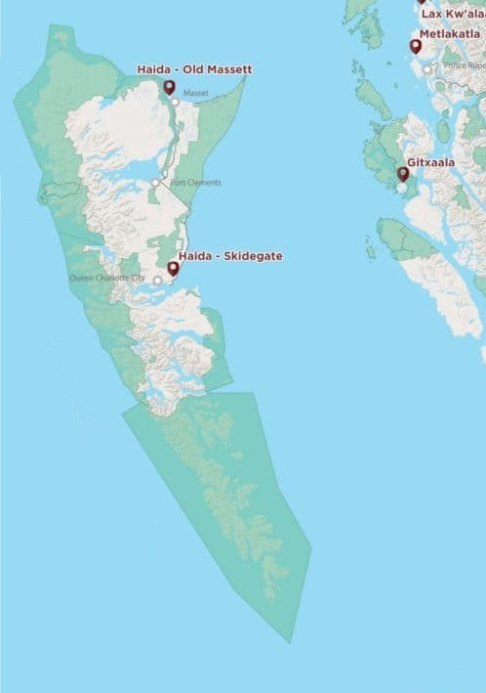The Haida Gwaii land use planning process took place 2002-2004 and was followed by government-to-government negotiations that culminated in the Haida Gwaii Strategic Land Use Agreement (SLUA) in 2007. The Haida Gwaii SLUA[15] covers 1,004,000 hectares (2,480,000 acres), defining zoning for new conservancies, special value areas, and an ecosystem-based management (EMB) operating area. Special value areas included wildlife habitat for species of significant cultural importance to the Haida Nation. Management objectives in the Haida Gwaii Strategic Land Use Agreement became land use objectives which were legally established by ministerial order on December 17, 2010.

**Figure 4: Haida Gwaii Protected Areas**

In 2011, the Haida Nation and the Province of BC signed a *Reconciliation Protocol agreement* to create a more productive relationship through a joint decision-making process, resulting in a more respectful approach to land and natural resource management on Haida Gwaii. The Protocol confirms an incremental step in a process of reconciliation of Haida and Crown titles (Haida Nation and Province of BC, 2009). The agreement created the Haida Gwaii Management Council, which has the authority to make joint determinations related a specific set of strategic land and resource decision types and resource decision types. The Haida Gwaii management council was convened in 2011 and became the decision-making body for land use objectives on Haida Gwaii.

*Source: Coast Funds*

The Haida now have a title case before the BC Supreme Court, building on all of the above, which they hope will settle aboriginal land claims on private land and land submerged by the sea (not just Crown or public land).[16]

***Summary and relevance to Myanmar***

In summary, Canada’s Constitution was understood for many years to mean that the federal and provincial Crown holds the rights to land, and to decision-making on that land, and while Aboriginal title constitutes a beneficial interest in the land, the underlying control of that is retained by the Crown. Protracted processes have therefore evolved over the years to define what means. In the context of many indigenous groups that signed treaties as Canada expanded west, upon signing those treaties, they extinguished their claim to their full traditional territories. Indigenous people (mostly in the Province of British Columbia) who never signed treaties have retained the leverage necessary to assert their aboriginal rights and title. However, modern treaty processes are decades-long efforts, and only a handful have reached the fifth and final stage of completion. Other measures such as government-to-government negotiated agreements on land use, acquiring forest tenure rights, and co-management arrangements are interim measures, that are steps on the way toward full recognition of aboriginal rights and title, and self-government. The historic Supreme Court of Canada decision, in Tsilhqot'in Nation v. British Columbia (2014) granted a declaration of Aboriginal title, affirmed the territorial nature of Aboriginal title, affirmed that it existed prior to Europeans asserting sovereignty, and rejected the legal test advanced by Canada and the provinces based on “small spots” or site-specific occupation.

Wilson-Raybould (2017) noted that the Supreme Court of Canada decision in *Tsilhqot’in* begs the next big question, which is “what laws will apply to the (Aboriginal) title lands so proven.” She notes, “The answer is, of course, a combination of laws in accordance with the constitutional division of powers and the rules of federalism as they are evolving. It will be a combination of Tsilhqot’in law, provincial and federal law. And the relationship between laws will have to be addressed through discussions and agreements among the parties or if necessary, ultimately determined by the courts.”

In 2018, the Government of Canada began a process to reform its laws and policies to ensure the rights of Indigenous peoples, and the treaties and agreements the government has signed are upheld, through a ‘Recognition and Implementation of Indigenous Rights Framework.’[17] There are on-going Treaty negotiations,[18] and multi-level governance is evolving. Unfortunately, this type of cooperative federalism continues to place a large burden on Indigenous peoples to demonstrate their claim to Aboriginal rights and title, and for their self-government to be respected by provincial and federal levels. Former Attorney General and Minister of Justice Wilson-Raybould (2017) stated, “it is not for the federal government to dictate what self-government must look like, but for Indigenous nations to set a path forward, and the federal government to learn to act as partners in operationalizing and supporting that path as appropriate.”

**3. Ethiopia**

***Background***

Ethiopia’s politics of ethnicity are set in a history of inequality between ethnic groups. The Amhara were perceived as the ruling group, and Amharic language prevailed, up until 1991. For most of the 20th Century, ethnically based movements were oppressed. Since the Ethiopian People’s Revolutionary Democratic Front (EPRDF), came to power in 1991 and introduced the concept of ethnic self-determination, Ethiopia has transitioned from suffering from large-scale conflicts between a centralized state and ethnically based liberation fronts to more stability (Aalen, 2011), though problems have been escalating. Ethiopia adopted *ethnic federalism* in the early 1990’s and is now geographically divided into nine ethno-linguistically based regional states and two chartered cities (including the capital Addis Ababa) (see map). Five of the nine states are predominantly inhabited by one particular ethnic group.

Though the census lists more than 90 ethnic groups, there are only nine ethnically defined regional assemblies with rights for the officially designated majority ethnic group. Ethnic groups do not live only in a discrete “homeland” territory but are also dispersed across the country. Non-native ethnic minorities live within every ethnic homeland, thus, there are ‘endless minorities’ (Mamdani, 2019). The mobilization of ethnic militias is on the rise, with paramilitaries or ethnic militias, initially established as counterinsurgency units, increasingly involved in ethnic conflicts, mainly between neighboring ethnic states, and in conflicts between native and non-native groups. Nearly a million Ethiopians have been displaced from their homes by escalating ethnic violence since 2012 (*ibid*). The growing discontent and protests since 2014 are based on a confluence of causes, but chief among them have been questions of land and territory under ethnic federalism—having to do with the delineation of ethno-regional borders and the relative prioritization of land access for the indigenous population and outside investors (Lavers, 2018).

**Figure 5: Ethiopia’s regions and zones**

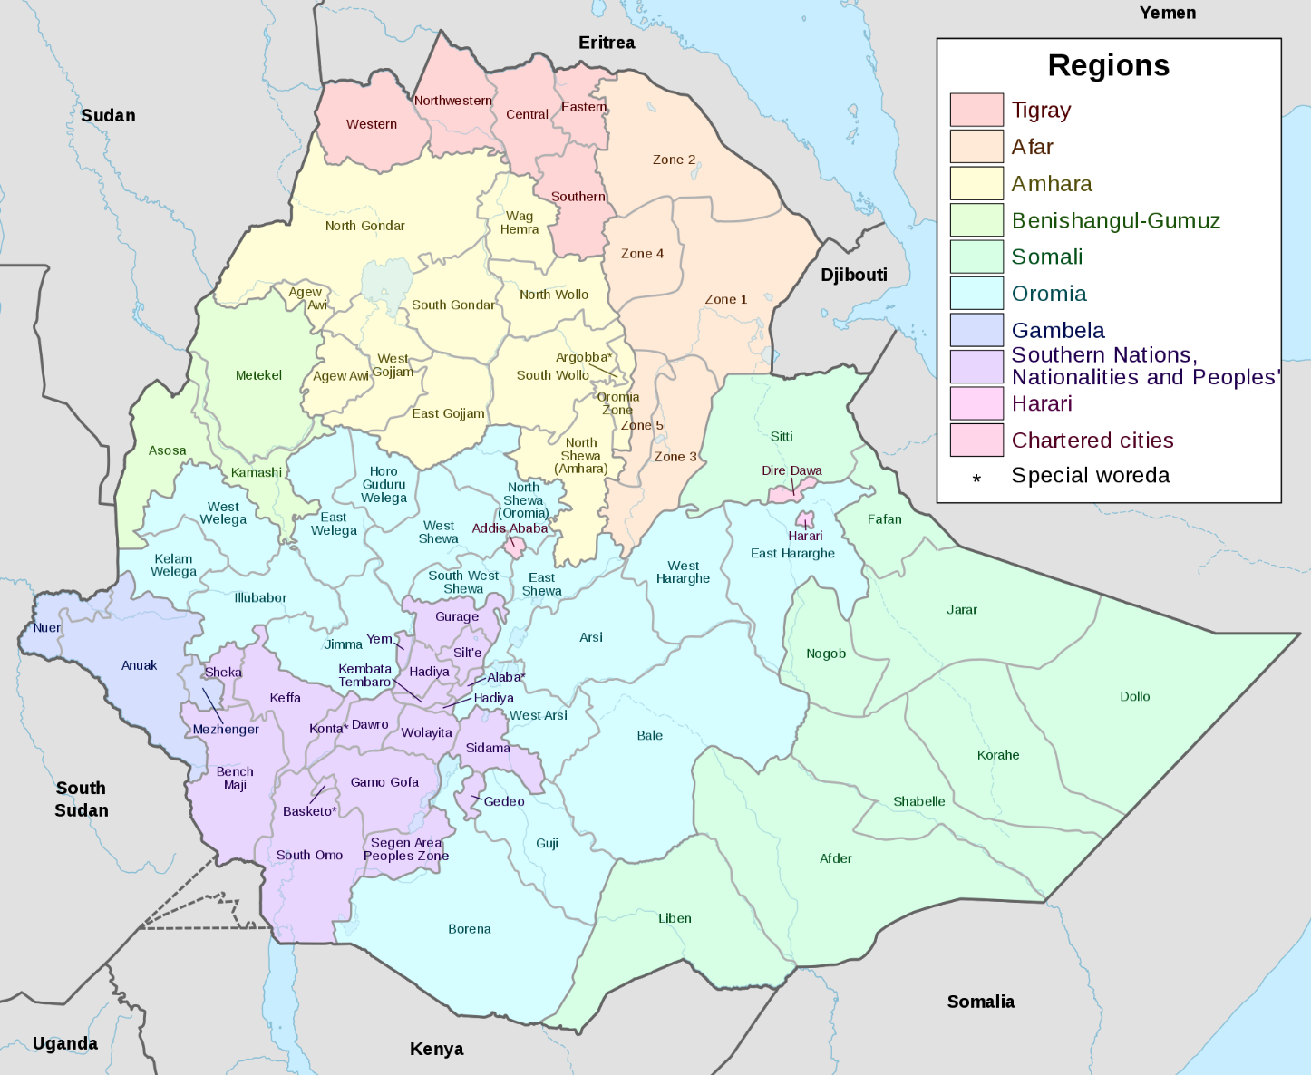

***Constitution***

The ethnic-based political parties and liberation fronts that negotiated the new Constitution after 1991 were primarily concerned with nationality and ethnicity after long suppression of the cultural and political aspirations of the ethnic communities that inhabit the country. Ethnicity was thus the basis for the reorganization of the Ethiopian state, and drafting of the Constitution (Fessha, 2019). The Constitution of 1994 states that every, “Nation, Nationality and People in Ethiopia has an unconditional right to: self-determination, including the right to secession; speak, to write and to develop its own language; to express, to develop and to promote its culture; and to preserve its history; a full measure of self-government which includes the right to establish institutions of government in the territory that it inhabits and to equitable representation in state and Federal governments (Article 39)(Ethiopia, 1994).

*Source: Wikipedia*

In the drafting of the Constitution, competing political forces were largely excluded from the process. The result was the federal system, the major institutional framework of the new government, being linked to the specific interests of the actors behind it (e.g. the EPRDF). Thus, these basic structures of governance are therefore viewed as not being independent of political party influence, and neutrality and legitimacy was eroded as a result (Aalen, 2011).

Although the right of nationalities to self-determination is constitutionally safeguarded, it is still the most contested principle in Ethiopian political life (Aalen, 2011). It is also because of the elevation of ethnicity to a primary political identity that the federation has to continuously entertain demands from some ethnic groups that, in search of ‘their homeland’, are demanding to be transferred from one state to another as the system has left them with the feeling of being outsiders in the area they have traditionally inhabited. It has also relegated millions of individuals to second-class citizens. Individuals that do not belong to the locally empowered group often face discrimination in areas of political rights, employment and other benefits offered by the states (Fessha, 2019).

Ethiopia’s Constitution stipulates that the powers and functions of the Federal Government are to formulate and implement the country’s policies, strategies and plans in respect of overall economic, social and development matters, and to enact laws for the utilization and conservation of land and other natural resources, historical sites and objects. Therefore, the powers and functions of States are to enact and execute the state constitution and other laws; formulate and execute economic, social and development policies, strategies and plans of the State; **administer land and other natural resources in accordance with Federal laws;** levy and collect taxes and duties on revenue sources reserved to the States and to draw up and administer the State budget (Article 51) )(Ethiopia, 1994).

***Recognition of indigenous land rights and title in law and policy***

Long before the Constitution of 1994, the Derg regime (1974–91) nationalized all rural land in 1975, calling for ‘land to the tiller,’ and the destruction of the feudal landholding class. The Derg began with an intent for land to be owned by the people, but shifted by 1975 to the public/state ownership of all rural land, distributing access rights to land through Peasant Associations. In practice, the distribution of land access rights by Peasant Associations included cases of corruption and bribery. The Derg replaced the dominance of feudal landlords with the dominance of the state, with Peasant Associations as instruments of control rather than allowing peasants to develop and promote self-administration (Chala, 2016).

When the Constitution of 1994 passed, the country was subdivided into different regional states, each with the right to exercise independent lawmaking, executive and judicial powers, but administering land and other natural resources in accordance with Federal laws. The Derg land policy was retained, with central government control over land and decision-making. As per the Constitution, land administration was devolved to regional governments, which were required to formulate land proclamations within the framework of the federal land policy. This created a contradiction between Ethiopia’s land policy, which gives smallholder farmers equal access rights to land, and ethnic federalism. Despite the implications of ethnic federalism for land administration, however, regional land proclamations—in line with federal land policy—do not mention ethnicity. Lavers (2018) identifies that the Oromiya land proclamation states that ‘any resident of the region’ has the right of access to land. Furthermore, when asked about the potential for ethnicity to influence land administration, the head of the federal Land Use Administration denied that there could be any ethnic differentiation in land rights: ‘ethnicity should not influence policy, farmers are farmers’ (*ibid*).

Most importantly, conflict has arisen due to the lack of real control over land by peasants, and the dominance of control by the State through the retention of rights and restrictions on the transferability of land use rights. Further, when the state needs resources, governments can make decisions and allocate uses without compensation or community consultation. This historical trend of state hegemony and peasant subordination therefore continues, and other relevant stake holders such as farmers, civil society and businesses are not involved in land policy decision making (Chala, 2016).

The dominance of one political party—the EPRDF—through all levels of government also undercut the federal system’s ability to accommodate ethnic diversity (Aalen, 2011).

Representatives of each ethnic group within the regional states were given the right to be represented in the institutions at central level. These arrangements upheld the central principle of federal systems – that the regional units are autonomous from central government, while central government incorporates regional units into its decision-making procedures according to constitutional mandate. However, the centralized party system under the EPRDF essentially controlled regional governments, which undermined the regional governments ability to operate independently from the central government (Chala, 2016).

Ethnic federalism therefore has important implications for land administration. Not only does federalism associate ethnic groups with defined territories, but, by providing the right to secession, it also explicitly prioritizes the land rights of ethnic groups over those of individuals. This type of federalism provides that each ethnic group has its own home region, but also implies that ethnic outsiders have a weaker claim to land than indigenous inhabitants. In practice, then, individuals are citizens of ethnic regions, rather than of Ethiopia. This sits in direct opposition to the land policy, which accords all Ethiopian farmers equal rights to land rights, and is further complicated by the territorial implications of ethnic federalism which essentially provide lesser rights for non-indigenous ethnic minorities (Lavers, 2018).

***Sub-national legal decisions and practice***

In practice, neo-customary tenure systems are followed in many parts of the country, despite State control. Land is viewed in an intergenerational manner, as having “belonged to one’s parents, grandparents, great grandparents, and will belong to one’s children, grandchildren, and great grandchildren (Chala, 2016).” Land is also viewed as common property of the extended family, the clan, and the ethnic tribe (*ibid*). In the federal system, the regional government holds the authority to oversee land (in accordance with federal policy and law), however in the neo-customary tenure system, clan elders are responsible. Local citizenship in neo-customary tenure systems is based on the clan, with excludes non-indigenous ethnic people, as well as other indigenous clans. This is in contrast to federalism, which provides equal rights for all those from the dominant ethnic group of the region (Lavers, 2018). Thus, the locus of authority, territorial jurisdiction and principle of citizenship differ between the concept of state ownership, ethnic federalism, and neo-customary tenure systems.

The federal state, despite according nominal decentralized power to regional and local authorities, is stronger than any previous Ethiopian state and has developed structures of central control and top-down rule that preclude local initiative and autonomy (Abbink, 2012). Recent government promotion of large-scale agricultural investments prioritized land access for outsiders over that of politically marginal indigenous populations. In the process, pastoralists and shifting cultivators have found their land access curtailed in direct contradiction of the principles of ethnic federalism (Lavers, 2018). In other contexts, and in stark contrast, the territorial implications of ethnic federalism have provided a rationale for the displacement of ethnic minorities in response to growing resource shortages. Finding a way to incorporate neo-customary tenure systems is only more recently being considered, but not systematically. There is also concern the government has sought to reinvigorate and co-opt customary tenure as a means of pursuing its own policy objectives in recent years (*ibid*).

The current dialogue on federal reform in Ethiopia is exploring how a different kind of federation based on territory, not ethnicity, can be embraced, in which where rights in a federal unit are dispensed not on the basis of ethnicity but on residence (Mamdani, 2019). Fessha (2010) argues that Ethiopia’s experience shows that federalism, as institutional device, is not enough to respond to the challenges of ethnic diversity. A federal design that is constructed to accommodate ethnic diversity must go beyond the traditional institutional features of a federation, to include institutional features that, a) reflect the multi-ethnic character of the state, b) contain institutional designs that promote the principle of shared rule in the most contested political space and at all levels of government, and c) a judicially enforceable bill of rights, and extension the institutional principles of self-rule and shared rule to respond to the concerns of intra-substate minorities (*ibid*).

**4. Brazil**

***Background***

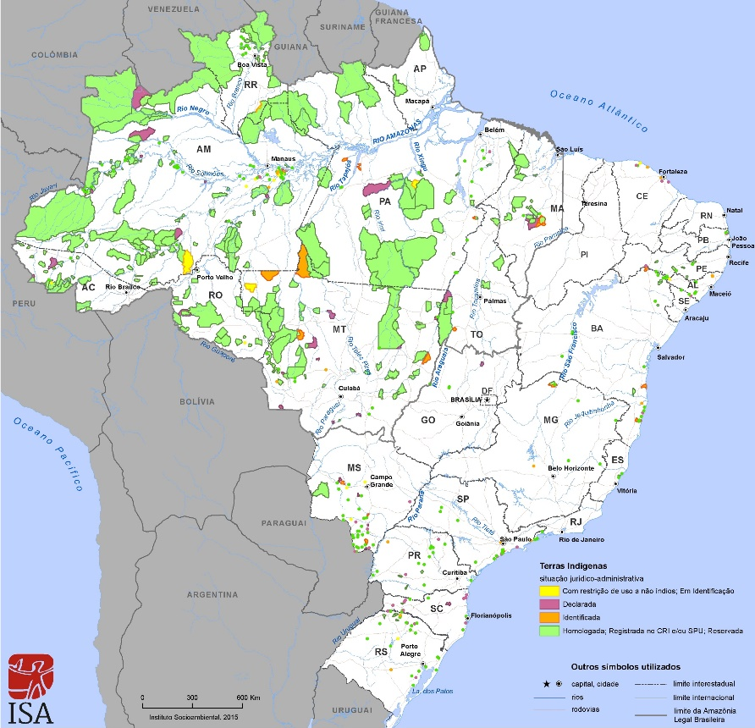Brazil’s indigenous people existed across the country prior to Portuguese colonization. Between the 16th and 20th Centuries, the colonization of Brazil, from East to West, involved often violent force against indigenous populations. According to the 2010 census of the Brazilian Institute of Geography and Statistics, the indigenous population is 896,917 people, distributed among 305 ethnic groups, speaking 274 languages. Among indigenous persons over the age of five, only 37.4% speak an indigenous language, while 76.9% speak Portuguese (IWGIA, 2019). In Brazil, an indigenous territory or indigenous land (referred to in Portuguese as *Terra Indígena* (TI)) is an area inhabited and exclusively possessed by indigenous people. There are 713 indigenous territories in Brazil, with a total area of 117 million ha., or about 13% of the country's land area (see Figure 3). Ninety-eight percent of indigenous territories are in the Amazon. While recognition of indigenous land rights occurred under the 1988 Constitution, and efforts evolved since then to recognize and demarcate indigenous territories, new threats risk that progress, and have garnered international attention. Indigenous people have come under attack by the National Rural Congress, by interests seeking to utilize land that have been granted mining or timber and agricultural concessions, and attempts by the new President, Jair Bolsonaro, to weaken the National Indian Foundation (FUNAI).

**Figure 6: Location and extension of Indigenous Lands in Brazil**

This recent shift raises questions about the extent of rights indigenous people have via the 1988 Constitution, and how it is possible for these to be so strongly infringed upon with the change in political climate. Particularly the isolated or recently contacted indigenous people are under increasing threat from illegal loggers, land-grabbers and miners who encroach on their territories. Violent land invasions have increased, with 153 indigenous territories invaded since January 2019 (compared with 76 last year), according to a recent report by Brazil’s Indigenous Missionary Council (Guardian, 2019).

*Source: Instituto Socioambiental, 2015. https://pib.socioambiental.org/en/Location_and_extension_of_Indigenous_Lands*

***Constitution***

The first major step towards indigenous rights occurred in 1973 with passage of the law “Statute of the Indigenous People” (Law 6.001/1973). Section IX, article 2, states that, “In order to protect indigenous communities and to preserve their rights, [the Statue] will guarantee that they [native Brazilians] have permanent possession of the lands in which they live, granting them exclusive utilization of the natural wealth and all the utilities found in those lands.” Nevertheless, FUNAI held a role more akin to being a guardian of indigenous people, and indigenous discontent with this led to the changes finally realized in the 1988 Constitution (Cunha, 2018).

The 1988 Constitution of Brazil contains a number of Articles relating to its indigenous population. Article 231 recognizes that, “Indians shall have their original rights to the lands they traditionally occupy, it being incumbent upon the Union to demarcate them, protect and ensure respect for all of their property.” Article 231 states, “The lands traditionally occupied by Indians are intended for their permanent possession and they shall have the exclusive usufruct of the riches of the soil, the rivers and the lakes existing therein (Brazil, 1988).” The role of the Union government in overseeing Indian affairs is stated in various sections of the Constitution. Article 20 asserts that lands traditionally occupied by the Indians are the property of the Union, and Article 22 states that the Union has the exclusive power to legislate on Indian populations.

The Constitution states that the National Congress holds the authority to allow, in Indian lands, the exploitation and use of hydric resources and the prospecting and mining of mineral resources (Article 49). Federal judges hold the authority to institute legal proceeding and trials relating to disputes over the rights of Indians (Article 109). One of the institutional functions of the Public Prosecution is to defend judicially the rights and interests of the Indian populations (Article 129) (*ibid*).” However, specific legislation on how to operationalize constitutional rights is still evolving (see the Brazilian Policy for Territorial and Environmental Management of Indigenous Lands (PNGATI) below).

***Laws, policy, and the role of courts in recognizing indigenous land rights and title***

Government policy and legislation to enact rights given in the 1988 constitution have been less than proactive. As the Brazilian Constitution functions as a framework for overarching principles and rights, it relies on other pieces of legislation enacted by the government to lay out the finer details of implementing these rights. But these pieces of legislation have not been enacted, and since the 1988 constitutional guarantees, the government pursued more of a hands-off policy regarding the implementation of indigenous rights, leaving indigenous peoples to struggle for changes in policy and centuries-old patterns of discrimination within society and government (Johnson-Steffey, 2004).

The *Indian Statute of 1973* (Law 6001/73) has been most problematic legislation, similar to Canada’s *Indian Act*. The statute defines the details of indigenous policy, contradicts the rights given to indigenous peoples in the 1988 constitution, and treats indigenous peoples as wards of the state (under the functions of FUNAI). Because it has never been replaced or revised, it still has a role in indigenous policy. However, the Brazilian Policy for Territorial and Environmental Management of Indigenous Lands (PNGATI) was established in 2012 (Presidential Decree no. 7,747 of June 5, 2012), with the objective of ensuring and promoting the protection, recovery, conservation and sustainable use of natural resources in indigenous territories and lands. This was a major step forward to create territorial and environmental management plans in indigenous areas.

Though the 1988 *Constitution* recognizes the indigenous land rights, and usufruct rights over the riches of the soil, the rivers and the lakes, in practice, a formal process of demarcation is required for a TI to be recognized. This has taken much longer than anticipated, has been subject to legal battles, and TI demarcations are frequently subject to illegal invasions by settlers and mining and logging companies.

FUNAI[19] is the official indigenous governance body of the Brazilian State. Created by Law No. 5,371 of December 5, 1967, linked to the Ministry of Justice, it is the coordinator and principal executor of the federal government's indigenous policy, and its mission is to protect and promote the rights of indigenous peoples in Brazil. FUNAI is responsible for promoting identification and delimitation studies, demarcation, land regularization and registration of lands traditionally occupied by indigenous peoples, as well as monitoring and inspecting indigenous lands. FUNAI also coordinates and implements policies to protect isolated and newly contacted people (FUNAI, 2019). The 1988 *Constitution* called for the federal government and FUNAI to complete demarcation of indigenous territories by 1993, yet the goal is roughly half-achieved 26 years later.

Demarcation has become a very complicated process. The Decree 1775 by the Brazilian President Cardoso in 1996, changed the steps FUNAI was required to follow to demarcate indigenous lands, by making the process more complicated and allowing for more interference from commercial interests, by allowing individuals or companies, from the beginning of the demarcation process until 90 days after FUNAI issued their report, to submit an appeal showing that the contested lands do not meet the qualifications of indigenous lands as stated in the constitution. Decree 1775 was viewed by many as part of a political deal to give the conservative business and state development interests of Brazil's Northern states access to indigenous lands and resources in exchange for the support of Northern politicians for a economic reform program before Congress (American Anthropological Association, 1996) Decree 1775 put 125 million acres of undemarcated land at risk, and ultimately led to more than 1,000 retroactive claims by corporations, landowners, and government entities such as the Brazilian Environmental Protection Agency and the government of the state of Rondonia (Johnson-Steffey, 2004). As a result, demarcation involves several Brazilian ministries and departments, and requires hundreds of hours of labor by staff of the underfunded and understaffed FUNAI to review border claims (*ibid*).

The pivotal legal case “Raposa Serra do Sol” (*State of Roraima vs. Federal Union and Indigenous People’s Council, 2008*) marked a decision by the Brazilian Supreme Court on demarcation. At issue was whether indigenous people’s lands were to be allocated in a continuous manner, or should be scattered throughout the state of Roraima, so to accommodate the existing rice plantations. The trial pitted rice farmers, the State of Roraima, part of the army, and groups of landless people, against Brazil’s national government, the Catholic Church, Indigenous Rights Council and Environmental Council. The side of the rice farmers argued that the reserve undermined Brazil's national integrity and the state's economic development, and proposed that it be broken up. After many violent conflicts, Roraima’s Senator sued the national government, on the basis that people and entities affected by the controversy hadn’t all been heard; there would be large commercial, economic and social impacts, as well as risks to national security and sovereignty; the scale of the land demarcation would create an imbalance of the Federation; and the ordinance violated the principle of reasonableness by privileging the tutelage of indigenous against the private sector. In their defense, the national government and Indigenous Council contended that Constitutional Articles 231 and 232 favoured indigenous rights over their occupied indigenous land; indigenous lands are the national government’s property, as per the Constitution; the state of Roraima was created after 1988 when 1988’s Constitution had already defined that indigenous land belonged to National Government. Brazil’s Supreme Court maintained that the demarcation should be continuous, and supported the position of the national government. Concerning potential damages to landowners impacted by the decision, it was held that the term “*originários*” contained in Article 231 of the Constitution, reflects the oldest and most powerful land tenure right. Further, the decision stressed that Brazil`s Constitution was upholding the legal institution of *indigenato*, which is the recognition by Brazilian government of immemorial indigenous land title, in order to assure natives have their social organization, customs, languages, beliefs and traditions, as well as tenure to the lands they traditionally occupy (Berardinelli, 2017).

The “Raposa Serra do Sol” ruling established a legal precedent. However, the extent of its influence to bring stability to the conflicts is not clear. An analysis of the outcomes of cases heard in regional federal courts in Brazil between 1999 and 2013, considering the individual judicial procedures and the specific laws and jurisprudences evoked by the federal judges in making their decisions, did not have an effect on the lower courts’ judgments. Rather, the research found, the 2009 decision triggered a proliferation of different interpretations among judges about how to analyze the land conflicts, thus changing the structure of the judges’ decisions (Monteiro, et al, 2019).

Over the last 20 years, demarcation procedures have decreased. Articulação dos Povos Indígenas do Brasil (APIB) identifies that one of the major obstacles for demarcation of indigenous lands is the influence exerted by the congressional rural caucus, which represents the interests of the agricultural and livestock businesses, with campaigns financed by agroindustry corporations linked to several legislation proposals that restrict the rights of the indigenous communities and criminalize rural reform (APIB, 2019).

The Territorial and Environmental Management Plans (PGTAs) of indigenous lands are important tools for PNGATI implementation, developed as a means to correct some of the challenges of demarcation. The PGTAs are strategic instruments to define and coordinate various public policies aimed at indigenous peoples, both at the federal, state and municipal levels. PGTAs are strategic instruments for indigenous peoples to define and plan the present and the future of their territories.

In 2019, President Jair Bolsonaro sought to place FUNAI under the Ministry of Human Rights, Family and Women, and transfer land demarcation powers to the Ministry of Agriculture (Reuters, 2019). However, Brazil’s National Congress overturned the changes, essentially nullifying the attempt.

***Sub-national legal decisions and practice***

The indigenous people living in Brazil face continual encroachment, and struggle to have their interests heard and respected in state and federal government. While their own governance systems are diverse and based on their own traditions, it is up to indigenous people in Brazil to fight mining, farming, ranching, and development pressures in their territories.

A good example is Yanomami,[20] which is the largest indigenous group in the Amazon, located in the rainforests and mountains of northern Brazil and southern Venezuela. It is a hunter-farmer society living in the rainforest, located between the states of Amazonas and Roraima and covers approximately 9,664,975 ha (23,883,000 acres), in the region between the Orinoco and Amazon rivers. The Hutukara Yanomami Association brings together the Yanomami subgroups, to implement the agreed statutes and legal provisions. Related to land, these include defending and representing the rights and interests of the Yanomami of the regions affiliated to the association in all instances inside and outside the Yanomami Indigenous Land; entering into agreements and agreements with public or private entities, with a view to the development and expansion of their activities; promote the elaboration of public policies of interest to the Indigenous who inhabit the Yanomami Indigenous Land (Hutukara Yanomami Association, 2011).

Efforts have focused on defining instruments for integrated territorial governance for indigenous lands through ‘Life Plans[21]’ and also ‘indigenous protocols.[22]’ The Life Plan provides a strategy to secure the sense of past, present and future of indigenous people in their territory. The indigenous protocol defines guidelines by which an indigenous group makes decisions on the environmental services in their territory and how to evaluate proposals from outside the community that affect it.

In summary, the Indigenous in Brazil are still viewed as wards of the State, have not been given autonomy to the degree granted in Constitution, demarcation has been slow, and the threats to their traditional ways of life and rights to their traditional territories are growing.

**5. How do these experiences pertain to similar challenges in Myanmar’s context?**

The experiences in Canada, Ethiopia and Brazil illustrate how federalism, as an institutional governance device, is not enough to respond to the challenges of ethnic diversity. Despite the Constitutional commitments to indigenous rights, in all three countries this has not worked out as planned for in Constitutions. The reasons for this differ between countries. Though rights to land and resources in all countries was enabled by the Constitution, the burden of proof was placed on indigenous people, who are in a disadvantaged negotiation position, or on federal agencies to make determinations, which have created more conflicts and discontent. In Canada, though the Constitution recognized existing aboriginal and treaty rights, it did not demarcate where this was to occur, what laws would apply in these areas, and how those laws or procedures would relate to the rest of the federal system. Thus, with so many unanswered questions, assertion of indigenous rights and title has been pressed in court cases, negotiated land use agreements and protocols, treaties, and consultative processes. Had the Charlottetown Accord passed a public referendum in 1992, which would have given Aboriginal people the right of self-government, the situation would likely be very different today. A similar process occurred in Brazil, where indigenous people hold the oldest and most powerful land tenure right under the Constitution, but these could only be determined by the demarcation of the indigenous territory, a process that was ultimately distorted and corrupted by forces opposing the existence of the indigenous people. Demarcation is also complicating treaty processes in British Columbia, where well over 100% of B.C. Crown land is claimed as the traditional territory of one or more of the province's 198 First Nations. However, in Ethiopia, the Constitution went so far as to recognize the main ethnic people in the declaration of the member states of the ethnic federal republic. This prioritized the main indigenous populations in these states, and created endless minorities, which only exacerbated ethnic conflict, and an over-reliance on ethnic identity, at the cost of a uniting federal identity. This has shaken the very foundation of the Republic, and created a constitutional crisis.

The disconnects between existing legislation and practice also complicated implementation of Constitutional principles. In Canada and Brazil, the *Indian Act* and the *Indian Statute,* respectively, have defined policies and modes of relationships between colonial governments and their indigenous populations that preceded the Constitution, and are difficult to undo unless the country’s legislative system is overhauled to reflect the change. Further, Canada and Brazil’s *Indian Act* and *Indian Statute*, defined a relationship in which Indians were essentially made wards of the state, with the government as trustee. The result in both countries has been disastrous for indigenous people in these systems. In Ethiopia, despite the formation of an ethnic federalist system, the pre-existing Derg regime was maintained after the adoption of the new Constitution, which resulted in land tenure (and management and administration) being disconnected from the ethnic customary governance systems. Rather, the distribution of land access rights by Ethiopian Peasant Associations in the Derg system undermined ethnic governance systems, and enabled co-option by central government, which maintained central control and decision-making. Not surprisingly, this also lead to a context ripe for corruption and bribery.

One insight is clear across all countries reviewed—despite identifying ethnic rights in constitutional documents, constitutions have often failed to provide necessary clarity. Thus, leaving it to the courts to interpret and decide constitutional intent can be a quagmire. Even precedent-setting court cases such as *State of Roraima vs. Federal Union and Indigenous People’s Council, 2008* (“Raposa Serra do Sol” in Brazil) do not guarantee judicial and legislative alignment with the ruling, and Canada’s experience mirrors this, though the situation may be improving.

Land and natural resources must be a central aspect of Constitutional indigenous/ethnic rights, as is evident in all three federal countries reviewed. Indigenous culture is tied to land, so defining land rights in the same section as Indigenous rights in a Constitutional setting makes clear this connection. In Myanmar, the Constitution of 2008 does not contain such recognition. However, the Constitution enables the Union government to assist to promote solidarity and respect among the National races and to enact necessary laws to protect the rights of the peasants (Union of Myanmar, 2008). The peace process seeks to find reconciliation between Union government and ethnic nationalities. As such, the National Ceasefire Agreement (NCA) and bi-lateral cease-fire agreements are the largest point of leverage ethnic armed organizations have. Including land and natural resources in these important agreements is crucial, to signal their importance in the solution set towards peace. These can be viewed as being treaties, similar to the modern treaties that have been negotiated in Canada (refer to Nisga’a). However, the NCA only includes two clauses related to land and natural resources: 1) avoiding forcible land confiscation in favor of land tenure security (§9), and 2) supporting environmental conservation and community consultation in the planning of projects impacting civilians in ceasefire areas (§25). These provisions do not recognize indigenous rights and title to their lands, in a federal system, but only reinforce Union government control and authority over ethnic lands. However, in Canada, treaties have centered on land and natural resources, as a basis point for many other aspects of the economy and culture. Settling these land claims has been at the forefront of defining Aboriginal rights.

Further, the current system of federalism gives very little authority to states/regions, and is silent on how a ‘third tier’ of governance and decision-making (e.g. ethnic governance) will be recognized in this system. Myanmar’s current *Constitution* (of 2008, additional amendments in 2015) does not devolve decision-making authority on land and natural resources to state/regions, or third-tier entities. That means in practice that all authority continues to be held with the Union government. **Interim Arrangements under the NCA, or a joint agreement under the UPDJC, or some other appropriate avenue, could be further expanded upon to define the processes by which reconciliation of ethnic people’s aboriginal right to their land and natural resources can be pursued.**

When it comes to land, consideration must be given to the locus of authority, territorial jurisdiction and principles of citizenship, and how they differ between layers of governance (Lavers, 2018). This is particularly relevant in considering indigenous/ethnic tenure systems in the context of a federal system. As the experience in Ethiopia shows, decentralization of administration (but lacking authority) to more localized power structures, under centralized control, can lead to corruption and new destabilizing power dynamics, such as customary and traditional power structures being co-opted to exert federal control locally. Also, in Ethiopia, the ethnic federalism system has highlighted ethnicity over other aspects of shared national identify, fuelling conflict. In contrast, the Canadian examples of First Nations governance systems, in which authority, territorial jurisdiction and principles of citizenship are grounded in the First Nation (e.g. Nisga’a, Haida, Tsilhqot’in, etc.), indigenous governance is increasingly respected. Indigenous governance can take many forms, but the examples of the Nisga’a, Haida, Coastal First Nations, and also Brazil’s Yanomami (and others) show how defining all relevant answers to the land issue, in the form of land management plans, zoning and so on, allows Indigenous nations to set the path forward, and provinces/states and the federal government can act as a partner to operationalize and support that path as appropriate.

As such the following can be a basis for considering the different aspects of authority and territorial jurisdiction (including the recognition of rights) and how that sits in relation to land designation options that allow indigenous people to define their traditional territory and related decision-making authority within a federal system containing a majority of public lands (as opposed to private lands)[23]:

A. The range of **engagement options for central and state/regional government** to recognize indigenous rights to land in a federal system in the above case studies, in order from giving least authority to most authority to indigenous governance bodies or regimes (See Figure 4):

*Consultation*—federal government or state government alerts indigenous people of a potential infringement on their aboriginal rights: In Canada, this has largely not occurred, and only through a Supreme Court decision in *Haida Nation v. British Columbia (Minister of Forests)* 2004 was a precedent set. Consultation forms the basis for free, prior and informed consent (FPIC). Without clear legal conditions set for consultation, practice shows it will not happen, and in cases of strong central government authority such as Brazil and Ethiopia, this is especially the case. In these countries, central government control over administering land and other natural resources in accordance with Federal laws, and the dominance of federal laws over any enacted at sub-national levels, has been problematic. In a context such as Myanmar’s, where no Constitutional protection is given to ethnic people, there will be no basis to direct future statutory decision-makers to consult with ethnic people on issues that would impact their aboriginal rights and title.

*Revenue-sharing*—Though not a means to recognize indigenous rights to land or devolve decision-making authority, revenue-sharing from natural resources at least provides some revenue to indigenous people from economic activities occurring in their territories. While this can be enticing to communities that seek a cut of the revenue coming from their territories, without the link to land title and to the affirmation of Aboriginal rights and title, revenue-sharing has been criticized as ‘paying off’ aboriginal communities, while leaving communities with the economic and social burden of the pollution and waste. More recent revenue-sharing agreements in British Columbia have applied a ‘degree of infringement (on Aboriginal rights)’ and/or a percentage of revenue for the life of the project.[24] However, benefit- and revenue-sharing agreements often take away the First Nations legal and political rights respecting a certain project, in exchange for money or other benefits, and this is usually a high price for the First Nations to pay for the financial compensation they will receive (Sayers, 2015).

*Accommodation*—federal government or state government considers and acts upon the recommendation by aboriginal people on how to avoid infringement on their aboriginal rights: In Brazil, the demarcation process has been the means to implement this concept, but it has failed to achieve the goals identified in the Constitution, and is subject to political challenge from the rural development lobbies. Again, without Constitutional protections for indigenous rights in Myanmar, there would be no basis for considering how to accommodate indigenous interests.

*Shared decision-making and co-management*—both parties jointly share decision-making: Robust example is the Great Bear Rainforest agreements (Great Bear Rainforest Land Use Order and the Great Bear Rainforest (Forest Management) Act) and the Haida’s Gwaii Haanas Agreement, the Haida Gwaii Strategic Land Use Agreement, and the on-going work of the Haida Gwaii Management Council, formed after the signing of the 2011 *Reconciliation Protocol agreement.* Since these agreements direct all ministries to honor the terms of these agreements (including infrastructure, forestry, agriculture, mining, and so on), they define the reconciliation with First Nations across all levels of government, and with all actors, including the private sector. With mutual respect, these types of arrangements can be successful.

*Indigenous self-government*—federal government or state government recognizes and respects indigenous government, and signals in legislation how that affects jurisdictional and relationship aspects. Canada’s aboriginal treaties provide a very tangible example of how a ‘third tier’ of governance can be allowed and respected, within a federal system. The Nisga’a treaty makes clear that Nisga'a laws operate alongside federal and provincial laws, and the Treaty defines the rules by which conflicts or inconsistencies between laws will be addressed. Nisga'a Government authorities are subject to federal or provincial standards, where a "meet or beat" approach is taken. Child welfare is a good example of how this works. Nisga'a laws have priority if they meet or exceed provincial standards for child protection — but federal and provincial laws requiring the reporting of children in care continue to apply. This “meet or beat” approach occurs in many areas, including education, child and family services, adoption, and forestry.[25]

**Figure 7: Range of engagement options for federal and state government with indigenous people**



*Source: Author*

B. This sits in relation to the range of **land designation options that allow indigenous people to define their traditional territory and related decision-making authority and responsibility** in the above case studies, for central and state/regional government to recognize indigenous rights to land. These are listed in order from giving least authority to most authority to indigenous governance bodies (see Figure 5):

*Central government holds ownership rights over land, devolves limited authority to state government, and does not recognize customary land use and rights:* This has been the case across many countries, and is the main source of conflict. It does not allow indigenous people to define their traditional territories and grants to decision-making authority. In Ethiopia it has resulted in a disconnect between the older Derg system and ethnic federalism. This can also include provincial/state government holding ownership rights over land, and central government devolves legislative powers to state government on land, but also does not recognize customary land use and rights. In Canada, this was the case up until the 1982 Constitution, which finally acknowledged these rights, and the last 37 years has been spent defining what the Constitutional rights mean practically, and how reconciliation can be carried out.

*Central government holds ownership rights over land, delegates authority to a federal agency to oversee indigenous people’s affairs and land*: As per the *Indian Act* in Canada and *Indian Statute* in Brazil, this model usually involves an imbalance in power dynamics, disenfranchises indigenous people, and has relied on ‘reserve systems’ in Canada and demarcation in Brazil, both of which have failed for a variety of reasons listed above.

*Central government holds ownership rights over land, but grants usufruct rights*: In all three countries reviewed, this is essentially the case when Aboriginal rights have been considered but delegated authority is not granted, such as the right to hunt or fish in certain areas. Even with Constitutional protections for aboriginal rights, usufruct rights have failed to withstand competing pressures in Brazil (notably forces seeking to develop the Amazon and other rural areas). Indigenous people are still mostly marginalized in the land decision-making processes, so engagement is often reactive to pressures on the land, and not in a meaningful governance role. In British Columbia, Canada, it has failed to address unceeded traditional territory, and the need for recognition of those inherent land rights.

*Co-Management in federal system that recognize customary land use and rights:* Central government holds ownership rights over land, makes statutory decisions jointly with indigenous people*,* and oversees management jointly. In British Columbia, Great Bear Rainforest Agreements and Reconciliation Protocol between the Haida and the Province of British Columbia and the Haida Gwaii Management Council offer examples of how this can function. The government and indigenous bodies work in a collaborative manner. This can also include delegating monitoring and oversight of land management to indigenous people as with the Guardian Watchmen[26] in the Great Bear Rainforest. This option still does not resolve recognition of Aboriginal land rights and title, but could be a step along the way, and does acknowledge that they exist.

*Central government recognizes recognize customary land use and rights in some areas, and allows for self-governance (customary traditions) in these areas:* This does not go as far as the self-governance option, but can accommodate customary governance systems. It requires demarcation (which has been challenging in many jurisdictions, especially when there are overlapping land claims). This option should include legal protections so that self-governance areas are respected by all agencies and levels of government.

*Central government recognizes Aboriginal title and allows for self-government within federal system:* This is the best option for recognizing aboriginal rights, and providing for self-governance. Experience shows that this is highly feasible within federal structures. In the 2014 *Tsilhqot'in Nation v. British Columbia* Supreme Court of Canada ruling, the Court recognized “Aboriginal title constitutes a beneficial interest in the land, the underlying control of which is retained by the Crown.” But the Court went further and recognized its failure to uphold the Aboriginal group’s ownership rights, and decided to grant the first Court declaration of Aboriginal title in Canada. Canada’s (few) modern treaties are a good example of recognizing full aboriginal title to land, while remaining within a federal system. The Nisga’a treaty defines which lands and resources are owned by the Nisga’a, and the scope of matters under the exclusive legislative jurisdiction of the Nisga’a Lisims Government or where there may be shared jurisdiction with British Columbia or Canada, including the rules to resolve conflicts. Upon signing the agreement, federal land title or land registry laws no longer applied to any parcel of Nisga’a Lands. The Treaty states that federal and provincial laws still apply to Nisga’a Nation and fee-simple lands, but if there is any inconsistency or conflict between the Treaty and the provisions of any federal or provincial law, the Treaty will prevail (Nisga’a Nation and Province of British Columbia, 1999)

Woods (2019) summarizes EAO efforts to set up systems and departments to govern and administer territories, land and resources, and populations under their influence. The KNU, KIO, NMSP, and Karenni National Progressive Party (KNPP) have pursued such steps.[27] These generally recognize and complement customary management practices, and provide culturally appropriate service provision, such as health care and education. Several EAOs also have forestry and agriculture departments that manage land and natural resources under their territorial jurisdiction. NCA-signatory and non-signatory EAOs have updated and revised policies related to land, environment and natural resources. There does not appear to be any significant differences in policy intent or substance for those EAOs that are signatories to the NCA and those who are not (*ibid*).



**Figure 8: Range of land designation options that allow indigenous people to define their traditional territory and related decision-making authority**

*Source: Author*

All known EAO policies related to land and natural resources are anchored in customary resource ownership rights and practices, where local customary authority figures maintain their right to govern village affairs and land and resource management. Importantly, they also support integrity mechanisms to advance good governance and accountability, such as third-party oversight and monitoring committees, and the active participation of civil society and customary authorities (*ibid*). The Indigenous Community Conservation Area (ICCA) is a ‘territory of life’ that indigenous people and communities are advancing to protect their land, environment, rights, culture, knowledge and livelihoods. ICCA groups have formed in Tanintharyi, Bago, Magwe and Sagaing Regions, and Karen, Shan, Chin and Kachin States (Myanmar ICCA Working Group, 2018). The ICCAs in EAO areas are bottom-up approaches to document and strengthen customary and indigenous areas, protect these areas from land grabs and environmental destruction, secure appropriate legal protection, and promote the ICCA as an alternative to top-down conservation and land management. These areas can be compatible with EAO land, forest and natural resource policies. These are well suited to the second-to-last type of land designation option in Figure 5, which entails government recognizing recognize customary land use and rights in some areas, and allows for self-governance (customary traditions) in these areas. This could also be a step towards central government recognizing indigenous land title and rights and allowing for self-government within a federal system, but this would require legal recognition, such as in the Constitution or otherwise.

The fundamental question is to what degree have Myanmar’s ethnic people ceded their indigenous rights to land? In the cases with Canada, Ethiopia and Brazil above, the indigenous claim to land prior to the creation of the federal Union (or Republic) is the basis for territorial claims. This report is not a legal analysis, however there are grounds to assert that Myanmar’s ethnic regions never formally ceded their right to their land. In fact, the original Panglong Agreement signed in 1947 between the Burmese government under Aung San and the Shan, Kachin, and Chin[28] peoples clearly indicates that, “Though the Governor's Executive Council will be augmented as agreed above, it will not operate in respect of the Frontier Areas in any manner which would deprive any portion of these Areas of the autonomy which it now enjoys in internal administration. *Full autonomy in internal administration for the Frontier Areas is accepted in principle*.” It identifies that demarcating and establishing a future Kachin State is desirable. It stated, “Citizens of the Frontier Areas shall enjoy rights and privileges which are regarded as fundamental in democratic countries.” It continued the financial relations established between the Federated Shan states and the Burmese federal government, and envisioned similar arrangements for the Kachin Hills and the Chin Hills (Executive Council of the Governor of Burma, the Saohpas and representative of the Shan States, the Kachin Hills and the Chin Hills, 1947). **There is no wording in the Panglong Agreement that indicates that Frontier Areas were giving up their claim to their lands.**

Yet the Constitution of 1947 deviated from this respect for the autonomy of Frontier Areas, and that has been a source of conflict ever since.[29] Importantly, the 1947 Constitution did allow for “Provision to be made by law on principles of regional autonomy for delegating to representative bodies of such regions as may be defined in the law, specified powers in administrative, cultural and economic matters. A law embodying such provisions shall determine the rights, powers and duties of such representative bodies and their relations to the Parliament and to the Union Government (§ 91).” The State Councils were to be comprised of members of the Parliament representing that state (Union of Burma, 1947).

Under current Union government laws, Union government holds far more legislative authority and revenue capture ability in the areas of forests, agriculture, mines and oil fields, minerals, and more. Interestingly, agriculture was viewed in 1947 as an area under the state’s jurisdiction, and the states would also capture revenue from forestry. As stated in the Introduction, states have a limited legislative jurisdiction under the 2008 Constitution and revenue capture from land is limited to non-timber forest products and small-scale artisanal mining. The current dialogue in The Union Peace Conference - 21st Century Panglong does not yet point a way forward on how to reconcile these gaps between what was agreed to in 1947, and what is a reasonable allocation of authority between federal and state levels. Most importantly, the Union Peace Conference is so far very quiet on the ‘land question’ in relation to the indigenous rights of ethnic people to their lands. Yet, the land question should be at the heart of any contemporary agreements, as it is the basis for the economic and cultural future of Myanmar’s ethnic people. In this regard, it would be useful to explore how current ceasefire agreements and federal institution-building could ‘do not harm’ to ethnic indigenous rights, and hold the space to further define what this might look like, in a federal system that preserved the Union, while granting more autonomy to ethnic governance systems. That would include recognition of ethnic rights to land in their traditional territories, and their inherent rights to govern (in particular, recognizing traditional forms of governance), to make and enforce their laws, and to manage their lands, resources and institutions. With that as a basis point, it becomes clearer how to define steps that could be taken to build trust between different levels of government in an emerging federal system.

**6. References**

Aalen, L., 2011. The politics of ethnicity in Ethiopia: actors, power and mobilisation under ethnic federalism. Koninklijke Brill NV, Netherlands.

Abbink, J., 2012. Ethnic-based federalism and ethnicity in Ethiopia: reassessing the experiment after 20 years. Journal of Eastern African Studies; Volume 5, 2011 - Issue 4: Ethiopia's revolutionary democracy, 1991–2011. Available at: https://www.tandfonline.com/doi/abs/10.1080/17531055.2011.642516

American Anthropological Association, 1996. Brazil's Giant Step Backward on Indigenous Rights

The Threat to the Natural Environment and Rights of Indigenous Peoples Posed by Brazilian Presidential Decree 1775. Available at: https://web.archive.org/web/20070106155150/http://www.aaanet.org/committees/cfhr/rptbrazil.htm

Articulação dos Povos Indígenas do Brasil (APIB), 2019. PEC 2015. Available at: <http://apib.info/pec-215/>

British Columbia Treaty Commission, 2019. Annual Report 2018. Available at: http://www.bctreaty.ca/sites/default/files/BCTC-AR2018.pdf

Brasil, 1988. Constitution of the Federative Republic of Brazil : constitutional text of October 5, 1988, with the alterations introduced by Constitutional Amendments no. 1/1992 through 64/2010 and by Revision Constitutional Amendments no. 1/1994 through 6/1994. Third edition. Available at: http://english.tse.jus.br/arquivos/federal-constitution

Berardinelli, A.L., 2017. Judicial Activism in Brazil’s Constitutional Court?: Studies in the Recognition of Brazilian Indigenous Tenure rights. Udayana Journal of Law and Culture , [Sl], v. 1, no. 1, p. 1-15, Jan. 2017. ISSN 2549-0680.

Bergner, K. and M. Jones, 2015. Mapping the territory: Aboriginal title and the Decision in Tsilhqot’in Nation v. British Columbia. Chapter in Proceedings of the 61st Annual Rocky Mountain Mineral Law Institute.

Brideau, I., 2019. The Duty to Consult Indigenous Peoples. Library of Parliament. Parliamentary Information and Research Service. Publication No. 2019-17-E.

Chala, T., 2016. Analysis of politics in the land tenure system: Experience of successive Ethiopian regimes since 1930. African Journal of Political Science and International Relations. Available at: https://pdfs.semanticscholar.org/312c/4776b3701c54468f7dd2c9d5b7308f0d1ec9.pdf

Coordenação das Organizações Indígenas da Amazônia Brasileira (COIAB), 2019. Letter of repudiation of the Indigenous Peoples of the 12th Ordinary Assembly of COIAB. Available at: http://apib.info/2019/09/29/carta-de-repudio-dos-povos-indigenas-da-xii-assembleia-ordinaria-da-coiab/

Council of the Haida Nation, 2019. History of the CHN. Website. Available at: http://www.haidanation.ca/?page_id=20

Cowie, S., 2019. Brazil’s uncontacted tribes face 'genocide' under Bolsonaro, experts warn. The Guardian, 7 October 2019. Available at: https://www.theguardian.com/world/2019/oct/07/brazil-bolsonaro-tribes-genocide-expert-warning

Cunha, M. 2018. Indigenous Peoples in the Constitution. Novos Estudos - CEBRAP. 37. 429-443. 10.25091/s01013300201800030002.

Ethiopia, 1994. Constitution Available at: https://www.wipo.int/edocs/lexdocs/laws/en/et/et007en.pdf

Executive Council of the Governor of Burma, the Saohpas and representative of the Shan States, the Kachin Hills and the Chin Hills, 1947. Panglong Agreement.

Fessha, Y.T., 2019. Ethiopia’s Ethnic Federalism: Part of the Problem or Part of the Solution. Blog, available at: https://verfassungsblog.de/ethiopias-ethnic-federalism-part-of-the-problem-or-part-of-the-solution/

Fessha, Y. T., 2010. Ethnic Diversity and Federalism: Constitution Making in South Africa and Ethiopia. Routledge (2016 reprint).

Government of Canada, 2018. Recognition and Implementation of Indigenous Rights Framework. Available at: https://www.rcaanc-cirnac.gc.ca/eng/1536350959665/1539959903708?wbdisable=true

Government of Canada, 1982a. Constitution Acts, 1867 – 1982. Available at: <https://laws-lois.justice.gc.ca/eng/Const/index.html>

Government of Canada, 1982b. Canadian Charter of Rights and Freedoms. Available at: https://laws-lois.justice.gc.ca/eng/const/page-15.html

Haida Nation and Province of British Columbia, 2009. Kunst’aa guu – Kunst’aayah Reconciliation Protocol. http://www.haidagwaiimanagementcouncil.ca/wp-content/uploads/2019/03/Kunstaa-guu_Kunstaayah_Agreement.pdf

Hutukara Yanomami Association/Hutukara Associação Yanomami, 2011. Hutukara’s New Statute. Available at: https://hutukara.org/index.php/hay/novo-estatuto-da-hutukara

International Work Group for Indigenous Affairs (IWGIA), 2019. Indigenous people in Brazil. Available at: https://www.iwgia.org/en/brazil/3391-iw2019-brazil

Johnson-Steffey, S., 2004. Still waiting after winning recognition in 1988, decade was dismal for Brazil’s indigenous. Cultural Survival Quarterly Magazine. Available at: https://www.culturalsurvival.org/publications/cultural-survival-quarterly/still-waiting-after-winning-recognition-1988-decade-was

Joseph, B., C. Joseph, 2019. Indigenous relations: Insights, tips and suggestions to make reconciliation a reality. Indigenous Relations Press.

Lavers, T., 2018. Responding to land-based conflict in Ethiopia: The land rights of ethnic minorities under federalism. African Affairs, Volume 117, Issue 468, July 2018, Pages 462–484, https://doi.org/10.1093/afraf/ady010

Mamdani, M., 2019. The Trouble With Ethiopia’s Ethnic Federalism. Opinion, New York Times. 3 January 2019. Available at: https://www.nytimes.com/2019/01/03/opinion/ethiopia-abiy-ahmed-reforms-ethnic-conflict-ethnic-federalism.html

Monteiro, G.F.A., L.LT. Yeung, S.M.Q. Caleman, L.S. Pongeluppe, 2019. Indigenous land demarcation conflicts in Brazil: Has the Supreme Court’s decision brought (in)stability?. European Journal of Law and Economics (2019) 48:267–290

Myanmar Indigenous Community Conservation Area Group, 2018. Brochure.

Nisga’a Nation and Province of British Columbia, 1999. Nisga’a Final Agreement. Treaty. Available at: https://www.nisgaanation.ca/sites/default/files/Nisga%27a%20Final%20Agreement%20-%20Effective%20Date.PDF

Parliament of Canada, 1992. Charlottetown Accord: Consensus Report on the Constitution, August 28, 1992, Available at: https://thecanadianencyclopedia.ca/en/article/charlottetown-accord-document

Republic of the Union of Myanmar, 2015. Law Amending the Constitution of the Republic of the Union of Myanmar.

Republic of the Union of Myanmar, 2008. Constitution of the Republic of the Union of Myanmar.

Reuters, 2019. Brazil's Bolsonaro hands indigenous land decisions back to farm sector. June 19, 2019. https://www.reuters.com/article/us-brazil-politics-indigenous/brazils-bolsonaro-hands-indigenous-land-decisions-back-to-farm-sector-idUSKCN1TK37O

Royal Commission on Aboriginal Peoples, 1996. Report of the Royal Commission on Aboriginal Peoples. Available at: <http://www.bac-lac.gc.ca/eng/discover/aboriginal-heritage/royal-commission-aboriginal-peoples/Pages/final-report.aspx>

Sayers, J., 2015. Revenue Sharing with First Nations in BC. Blog Post, First Nations in BC Knowledge Network. Available at: https://fnbc.info/blogs/judith-sayers/revenue-sharing-first-nations-bc

Statistics Canada, 2016. Statistics on Indigenous Peoples. Available at: https://www.statcan.gc.ca/eng/subjects-start/indigenous_peoples

Supreme Court of Canada, 2018. Mikisew Cree First Nation v. Canada (Governor General in Council), 2018 SCC 40, [2018] 2 S.C.R. 765. Available at: https://www.canlii.org/en/ca/scc/doc/2018/2018scc40/2018scc40.html

Supreme Court of Canada, 2014. Tsilhqot’in Nation v. British Columbia, 2014 SCC 44. Available at: <https://scc-csc.lexum.com/scc-csc/scc-csc/en/item/14246/index.do>

Supreme Court of Canada, 2004. Haida Nation v. British Columbia (Minister of Forests), [2004] 3 SCR 511, 2004 SCC 73. Available at: https://www.canlii.org/en/ca/scc/doc/2004/2004scc73/2004scc73.html

Union of Burma, 1947. The Constitution of the Union of Burma, 24 September 1947,

Effective 4 January 1948. Available at: https://www.ilo.org/dyn/natlex/docs/ELECTRONIC/79573/85699/F1436085708/MMR79573.pdf

Wilson-Raybould, J., 2017. Realizing a Nation-to-Nation Relationship with the Indigenous Peoples of Canada. Speech by the Honourable Jody Wilson-Raybould, Minister of Justice and Attorney General of Canada, at the University of Cambridge, UK.

Woods, K., 2019. Natural resource governance reform and the peace process in Myanmar. Forest Trends.

1. **Appendices**

**1. *Canada***

**1.a. Canada’s *Constitution Act of 1982***

Section 35: Rights of the Aboriginal Peoples of Canada

Recognition of existing aboriginal and treaty rights

**35.** (1) The existing aboriginal and treaty rights of the aboriginal peoples of Canada are hereby recognized and affirmed.

Definition of “aboriginal peoples of Canada”

(2) In this Act, “aboriginal peoples of Canada” includes the Indian, Inuit and Métis peoples of Canada.

Land claims agreements

(3) For greater certainty, in subsection (1) “treaty rights” includes rights that now exist by way of land claims agreements or may be so acquired.

Aboriginal and treaty rights are guaranteed equally to both sexes

(4) Notwithstanding any other provision of this Act, the aboriginal and treaty rights referred to in subsection (1) are guaranteed equally to male and female persons.

Commitment to participation in constitutional conference

**35.1** The government of Canada and the provincial governments are committed to the principle that, before any amendment is made to Class 24 of section 91 of the “*Constitution Act, 1867*”, to section 25 of this Act or to this Part,

* (*a*) a constitutional conference that includes in its agenda an item relating to the proposed amendment, composed of the Prime Minister of Canada and the first ministers of the provinces, will be convened by the Prime Minister of Canada; and
* (*b*) the Prime Minister of Canada will invite representatives of the aboriginal peoples of Canada to participate in the discussions on that item.

**1.b. Canadian Charter of Rights and Freedoms**

Section 2 defines fundamental freedoms, including freedom of conscience and religion; freedom of thought, belief, opinion, and expression; freedom of peaceful assembly; and freedom of association.

Sections 7 to 14 concern legal rights, including the right to life, liberty and security of the person; protection from unreasonable search and seizure; protection from arbitrary detention or imprisonment, etc.

Section 15 covers equality rights

*Equality before and under law and equal protection and benefit of law*

15. (1) Every individual is equal before and under the law and has the right to the equal protection and equal benefit of the law without discrimination and, in particular, without discrimination based on race, national or ethnic origin, colour, religion, sex, age or mental or physical disability.

*Affirmative action programs*

(2) Subsection (1) does not preclude any law, program or activity that has as its object the amelioration of conditions of disadvantaged individuals or groups including those that are disadvantaged because of race, national or ethnic origin, colour, religion, sex, age or mental or physical disability.

Section 25 is a General section:

*Aboriginal rights and freedoms not affected by Charter:*

25. The guarantee in this Charter of certain rights and freedoms shall not be construed so as to abrogate or derogate from any aboriginal, treaty or other rights or freedoms that pertain to the aboriginal peoples of Canada including

(a) any rights or freedoms that have been recognized by the Royal Proclamation of October 7, 1763; and

(b) any rights or freedoms that now exist by way of land claims agreements or may be so acquired.

*Other rights and freedoms not affected by Charter:*

26. The guarantee in this Charter of certain rights and freedoms shall not be construed as denying the existence of any other rights or freedoms that exist in Canada.

*Multicultural heritage*

27. This Charter shall be interpreted in a manner consistent with the preservation and enhancement of the multicultural heritage of Canadians.

*Rights guaranteed equally to both sexes*

28. Notwithstanding anything in this Charter, the rights and freedoms referred to in it are guaranteed equally to male and female persons.

**2. *Ethiopia***

1994 Constitution:

Article 25

*Right to Equality*

All persons are equal before the law and are entitled without any discrimination to the

equal protection of the law. In this respect, the law shall guarantee to all persons equal

and effective protection without discrimination on grounds of race, nation, nationality,

or other social origin, colour, sex, language, religion, political or other opinion,

property, birth or other status.

Article 39

*Rights of Nations, Nationalities, and Peoples*

1. Every Nation, Nationality and People in Ethiopia has an unconditional right to

self-determination, including the right to secession.

2. Every Nation, Nationality and People in Ethiopia has the right to speak, to

write and to develop its own language; to express, to develop and to promote

its culture; and to preserve its history.

3. Every Nation, Nationality and People in Ethiopia has the right to a full

measure of self-government which includes the right to establish institutions

of government in the territory that it inhabits and to equitable representation in

state and Federal governments.

4. The right to self-determination, including secession, of every Nation,

Nationality and People shall come into effect:

(a) When a demand for secession has been approved by a two-thirds majority

of the members of the Legislative Council of the Nation, Nationality or People

concerned;

(b) When the Federal Government has organized a referendum which must

take place within three years from the time it received the concerned council’s

decision for secession;

(c) When the demand for secession is supported by majority vote in the

referendum;

(d) When the Federal Government will have transferred its powers to the

council of the Nation, Nationality or People who has voted to secede; and

(e) When the division of assets is effected in a manner prescribed by law.

5. A "Nation, Nationality or People" for the purpose of this Constitution , is a

group of people who have or share large measure of a common culture or

similar customs, mutual intelligibility of language, belief in a common or

related identities, a common psychological make-up, and who inhabit an

identifiable, predominantly contiguous territory.

Article 47

Member States of the Federal Democratic Republic

1. Member States of the Federal Democratic Republic of Ethiopia are the

Following:

1) The State of Tigray

2) The State of Afar

3) The State of Amhara

4) The State of Oromia

5) The State of Somalia

6) The State of Benshangul/Gumuz

7) The State of the Southern Nations, Nationalities and Peoples

8) The State of the Gambela Peoples

9) The State of the Harari People

2. Nations, Nationalities and Peoples within the States enumerated in sub-Article

1 of this article have the right to establish, at any time, their own States.

3. The right of any Nation, Nationality or People to form its own state is

exercisable under the following procedures:

Article 51

Powers and Functions of the Federal Government

2. It shall formulate and implement the country’s policies, strategies and plans in

respect of overall economic, social and development matters.

5. It shall enact laws for the utilization and conservation of land and other natural

resources, historical sites and objects.

Article 52

*Powers and Functions of States*

2b. To enact and execute the state constitution and other laws;

2c. To formulate and execute economic, social and development policies,

strategies and plans of the State;

2d. To administer land and other natural resources in accordance with Federal

laws;

2e. To levy and collect taxes and duties on revenue sources reserved to the

States and to draw up and administer the State budget;

**3. *Brazil***

Article 20

those lands traditionally occupied by the Indians are the property of the Union (Article 20) The Union has the exclusive power to legislate on Indian populations (Article 22)

 The Union, the states, the Federal District and the municipalities, in

common, have the power to protect the environment and to fight pollution in any of its forms;

VII – to preserve the forests, fauna and flora;

VIII – to promote agriculture and organize the supply of foodstuff (Article 23)

The Union, the states and the Federal District have the power to legislate

concurrently on production and consumption;

VI – forests, hunting, fishing, fauna, preservation of nature, defense of the soil

and natural resources, protection of the environment and control of pollution (Article 24)

Article 49. It is exclusively the competence of the National Congress: to authorize, in Indian lands, the exploitation and use of hydric resources

and the prospecting and mining of mineral resources;

XVII – to give prior approval to the disposal or concession of public lands

with an area of over two thousand and five hundred hectares.

Article 109. The federal judges have the competence to institute legal proceeding

and trial of: disputes over the rights of Indians.

Article 129. The following are institutional functions of the Public Prosecution: to defend judicially the rights and interests of the Indian populations;

CHAPTER VIII

Indians

**Article 231**. Indians shall have their social organization, customs, languages, creeds

and traditions recognized, as well as their original rights to the lands they traditionally

occupy, it being incumbent upon the Union to demarcate them, protect and ensure

respect for all of their property.

Paragraph 1. Lands traditionally occupied by Indians are those on which they live

on a permanent basis, those used for their productive activities, those indispensable

to the preservation of the environmental resources necessary for their well-being

and for their physical and cultural reproduction, according to their uses, customs

and traditions.

Paragraph 2. The lands traditionally occupied by Indians are intended for their

permanent possession and they shall have the exclusive usufruct of the riches of the

soil, the rivers and the lakes existing therein.

Paragraph 3. Hydric resources, including energetic potentials, may only be

exploited, and mineral riches in Indian land may only be prospected and mined with

the authorization of the National Congress, after hearing the communities involved,

and the participation in the results of such mining shall be ensured to them, as set

forth by law.

Paragraph 4. The lands referred to in this article are inalienable and indisposable

and the rights thereto are not subject to limitation.

Paragraph 5. The removal of Indian groups from their lands is forbidden, except

ad referendum of the National Congress, in case of a catastrophe or an epidemic

which represents a risk to their population, or in the interest of the sovereignty of the

country, after decision by the National Congress, it being guaranteed that, under any

circumstances, the return shall be immediate as soon as the risk ceases.

Paragraph 6. Acts with a view to occupation, domain and possession of the lands

referred to in this article or to the exploitation of the natural riches of the soil, rivers

and lakes existing therein, are null and void, producing no legal effects, except in

case of relevant public interest of the Union, as provided by a supplementary law and

such nullity and voidness shall not create a right to indemnity or to sue the Union,

except in what concerns improvements derived from occupation in good faith, in the

manner prescribed by law.

Paragraph 7. The provisions of article 174*, paragraphs 3 and 4, shall not apply

to Indian lands.

**Article 232**. The Indians, their communities and organizations have standing under

the law to sue to defend their rights and interests, the Public Prosecution intervening

in all the procedural acts.

*As Paragraph 7 notes, provisions of Article 174 do not apply to Indian lands. The following is Article 174*:

Article 174. As the normative and regulating agent of the economic activity, the

State shall, in the manner set forth by law, perform the functions of control, incentive

and planning, the latter being binding for the public sector and indicative for the

private sector.

Paragraph 1. The law shall establish the guidelines and bases for planning of the

balanced national development, which shall embody and make compatible the national

and regional development plans.

Paragraph 2. The law shall support and encourage cooperative activity and other

forms of association.

Paragraph 3. The State shall favour the organization of the placer-mining activity

in cooperatives, taking into account the protection of the environment and the social economic furthering of the placer-miners.

Paragraph 4. The cooperatives referred to in the preceding paragraph shall have

priority in obtaining authorization or grant for prospecting and mining of placer

resources and deposits in the areas where they are operating and in those established

in accordance with article 21, XXV, as set forth by law.

1. Decision: https://www.canlii.org/en/ca/scc/doc/2014/2014scc44/2014scc44.html
2. See: https://www2.gov.bc.ca/gov/content/environment/natural-resource-stewardship/consulting-with-first-nations
3. Some examples here: https://fnbc.info/navigation-category/referrals
4. BC Treaty Commission: http://www.bctreaty.ca/
5. See: <https://www.nisgaanation.ca/> and https://www.nisgaanation.ca/treaty-documents
6. See: https://www.nisgaanation.ca/forest-management
7. See: https://coastalfirstnations.ca/
8. See: https://www2.gov.bc.ca/gov/content/industry/crown-land-water/land-use-planning/regions/west-coast/great-bear-rainforest
9. See: https://coastfunds.ca/great-bear-rainforest/
10. For a summary, see: https://greatbearrainforest.gov.bc.ca/tile/gbr-agreement-highlights/
11. See: http://www.haidanation.ca/wp-content/uploads/2018/10/Constitution-2018-10-signed.pdf
12. See: http://fngovernance.org/toolkit/best_practice/haida_nation
13. See: https://www.taanforest.com/
14. Timber supply analysis here: https://www2.gov.bc.ca/assets/gov/farming-natural-resources-and-industry/forestry/timber-tenures/tree-farm-licence/orders/tfl-60-haida-gwaii-tsr-analysis-report-april13-2012.pdf
15. See: https://www2.gov.bc.ca/gov/content/industry/crown-land-water/land-use-planning/regions/west-coast/haidagwaii-slua
16. See: https://www.haidagwaiiobserver.com/local-news/haida-title-case-to-be-heard-in-two-phases/
17. https://www.rcaanc-cirnac.gc.ca/eng/1536350959665/1539959903708?wbdisable=true
18. See all topics here: https://www.rcaanc-cirnac.gc.ca/eng/1100100028568/1529354090684
19. See: http://www.funai.gov.br/
20. See: https://hutukara.org/index.php
21. See: Yananawa Life Plan: https://www.forest-trends.org/publications/yawanawa-life-plan/
22. See: Ashaninka Protocol: https://www.forest-trends.org/publications/protocolo-de-servicos-ambientais-dos-ashaninka/
23. Countries that have predominantly private land holdings have a different set of circumstances.
24. Gas pipelines: <https://www2.gov.bc.ca/gov/content/environment/natural-resource-stewardship/consulting-with-first-nations/first-nations-negotiations/natural-gas-pipeline-benefits-agreements> and forest harvesting: https://www2.gov.bc.ca/gov/content/environment/natural-resource-stewardship/consulting-with-first-nations/first-nations-negotiations/forest-consultation-and-revenue-sharing-agreements
25. See: https://www.nisgaanation.ca/understanding-treaty
26. See: https://coastalfirstnations.ca/our-environment/programs/coastal-guardian-watchmen-support/
27. The KNU adopted a Land Policy and will soon pass a new Forest Policy; the KIO has drafted a Land Policy, a Forest Policy and a Natural Resources Policy; the NMSP and KNPP also have draft land policies waiting for final approval, and KNPP has started working towards a Forest Policy.
28. The Karenni States/Kayah did not sign the 1947 Panglong Agreement.
29. The Constitutions of 1972 and 2008 similarly do not reflect the Panglong Agreement.